

Faculty of Information Technology

Computer Systems Engineering Department

ENCS3320

Computer Networks

Project No. 2

➢ Instructors:

• Dr. Abdalkarim Awad

• Dr. Mohammed Helal

➢ Prepared By:

• Leen Abu Omar – 1190113

• Jihad Rashada – 1190777

# Abstract

This project contains two parts, the aim of the first part is to be able to use the Wireshark app and know how the DHCP, ICMP, and TCP protocols work by checking the packets fields for each protocol.

The aim of the second part is to be able to use the Cisco packet tracer app to connect PCs, routers, and switches correctly with assigning the required IP addresses and to ping from one PC to another without errors.

# Part 1

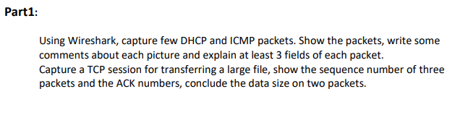

* DHCP
* **Definition:** dynamic host configuration protocol, is the protocol in which devices on a network used assigned with IP addresses automatically. The device can be assigned with a different IP address.

You can assign an IP address manually (static addressing) but it is not efficient as the DHCP.

* **Process:**
* Release: discard the assigned IP address to the client
* Renew: this allows the client to pull a new IP from the DHCP host by the next steps
* Discover: The client looks for DHCP server
* Offer: DHCP server responds with an offer
* Request: Client requests IP from the server
* ACK: Server assigns IP to the client and sends an acknowledgment
* Here are screenshots of the steps done to check the DHCP protocol:

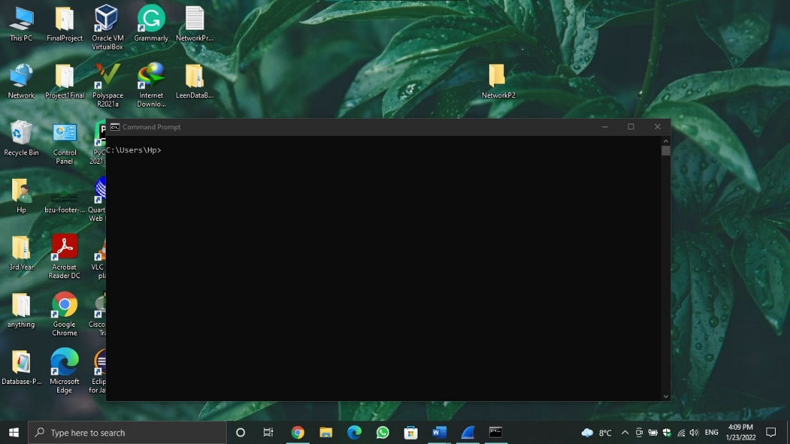

figure 1.1

* Figure 1.1 shows the WIFI connection before configuring any command, so the WIFI is connected.

In the following figure, a command ipconfig /release was configured in the command prompt screen and the WIFI was disconnected because by hitting this command, you discard the IP address for the client as shown in figure 1.2

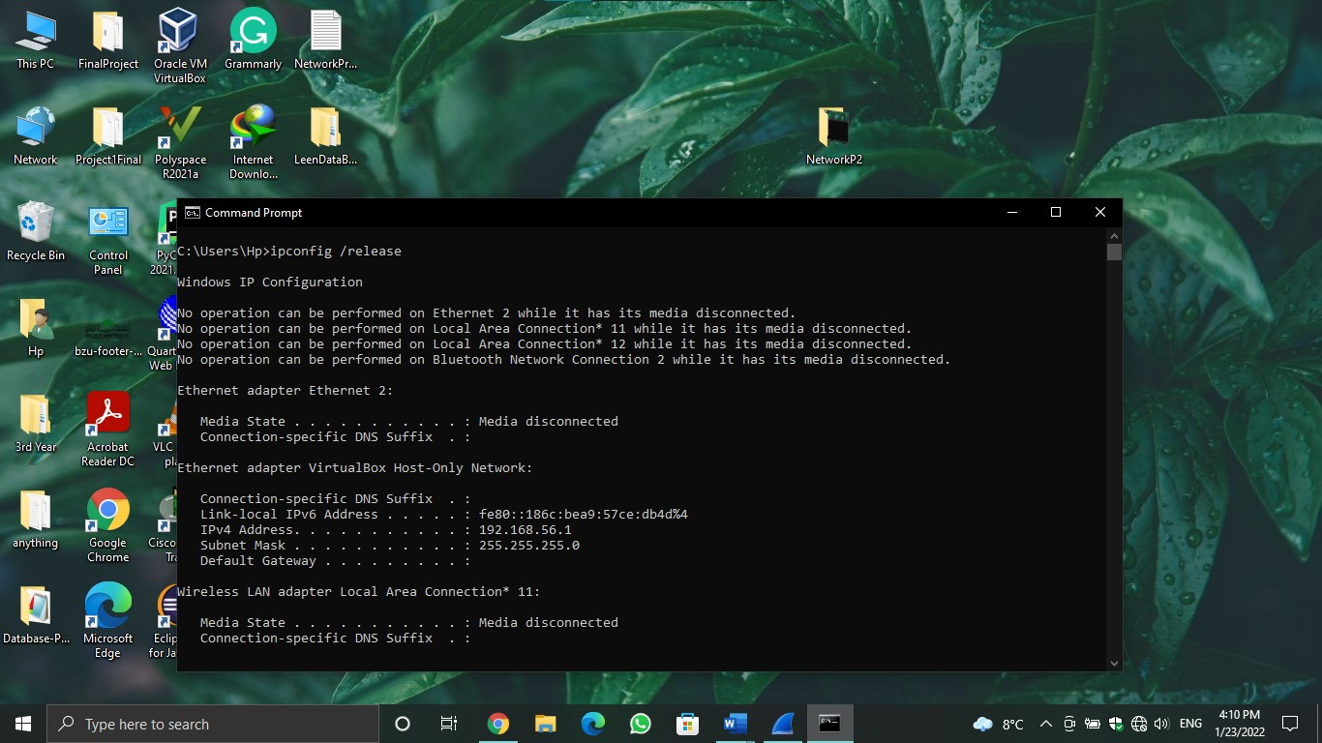

Figure 1.2

After configuring ipconfig /release, we will do some steps to find a DHCP server and ask it to give the client an IP address so ipconfig /renew command will be configured in the cmd screen as shown in figure 1.3

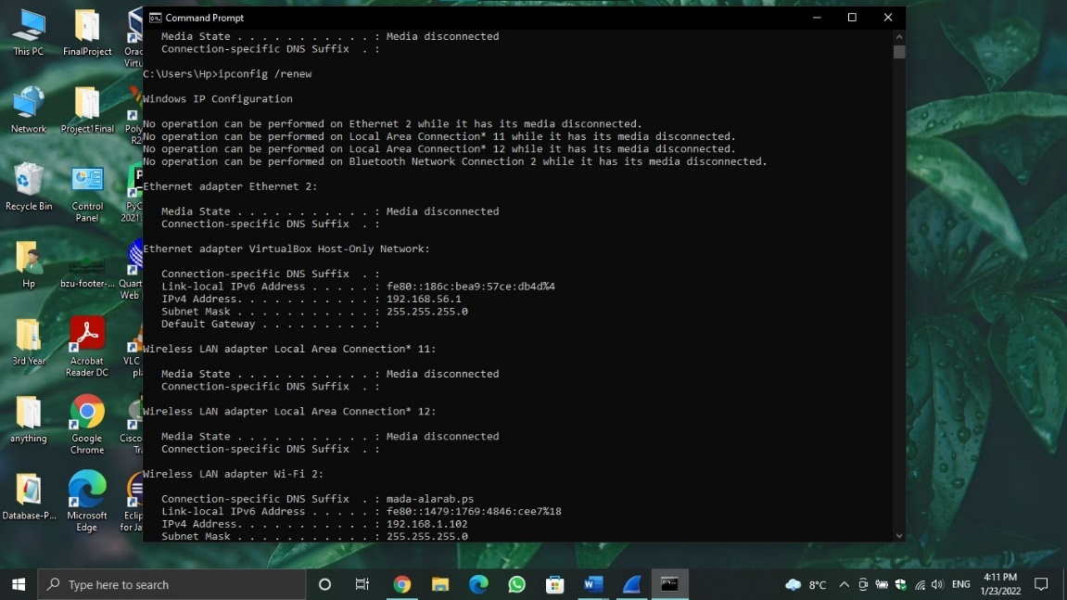

Figure 1.3

In figure 1.3, we notice that the WIFI was reconnected so the client got an IP address, to know the process done between the client and the DHCP server, see the following screenshots from Wireshark and notice the steps done to get an IP address.

* Here is a picture that carries all protocols before choosing DHCP protocol

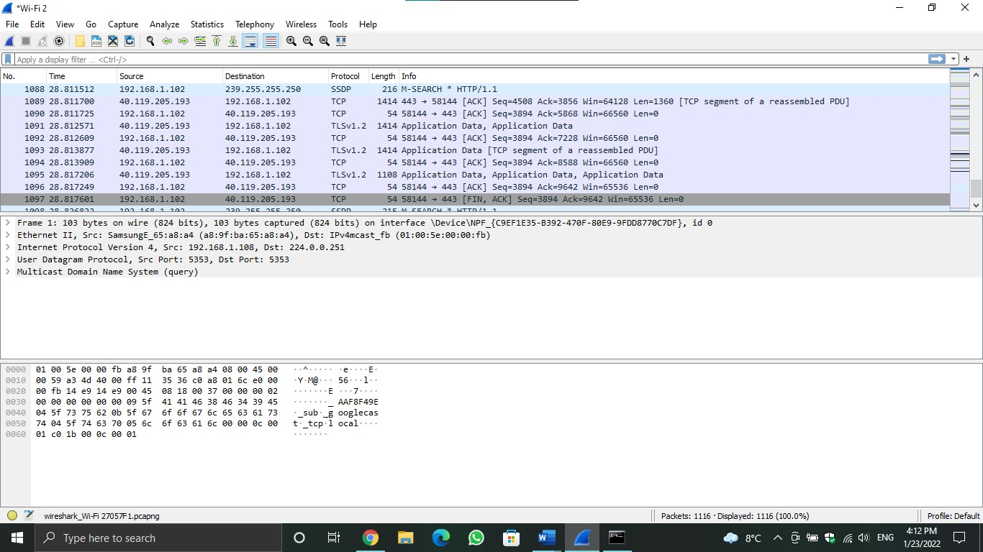

Figure 1.4

* The following figure (figure 1.5) shows the process for getting an IP address

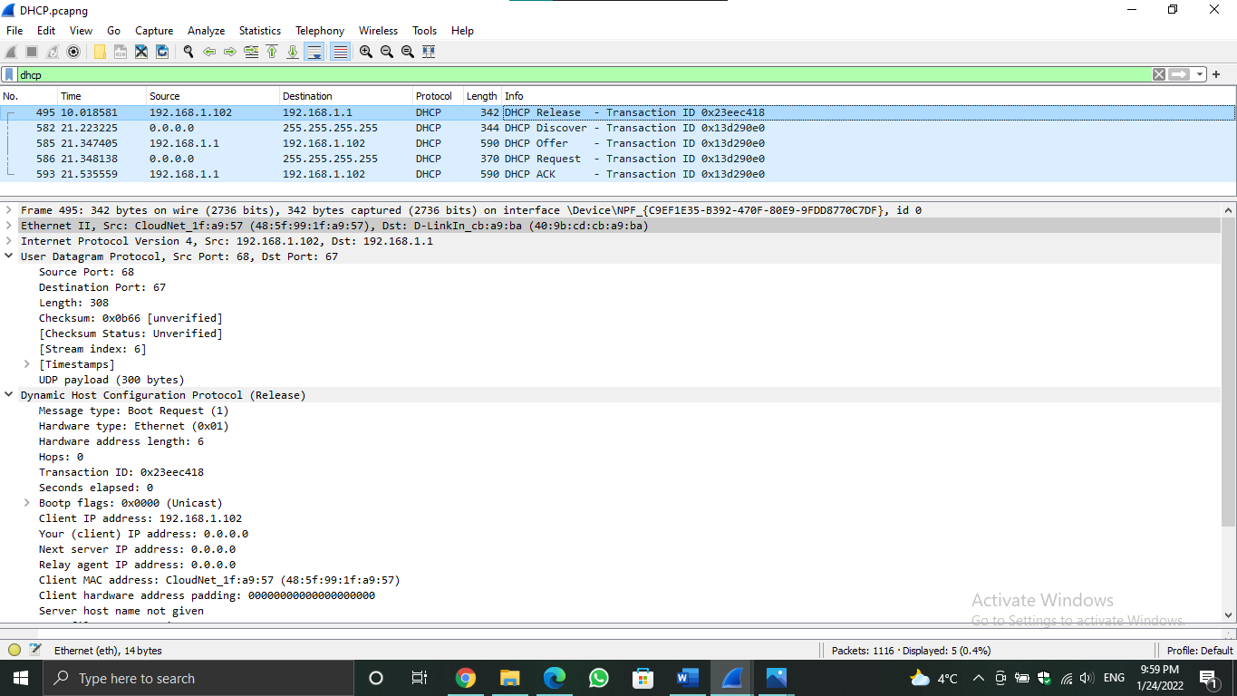figure 1.5

figure 1.5 shows the five steps described above.

In the first step(release), the client IP address was 0.0.0.0 which means it has no IP address because of the releasing command. The source IP was the client IP which is 192.168.1.102, and the destination was 192.168.1.1

* Message type: boot request (1) //it’s a boot request because the client is sending request signals
* Hardware type: Ethernet, data link layer
* Hardware address length: 6
* Hops: 0, the number of hops which the DHCP packet can travel before being discarded

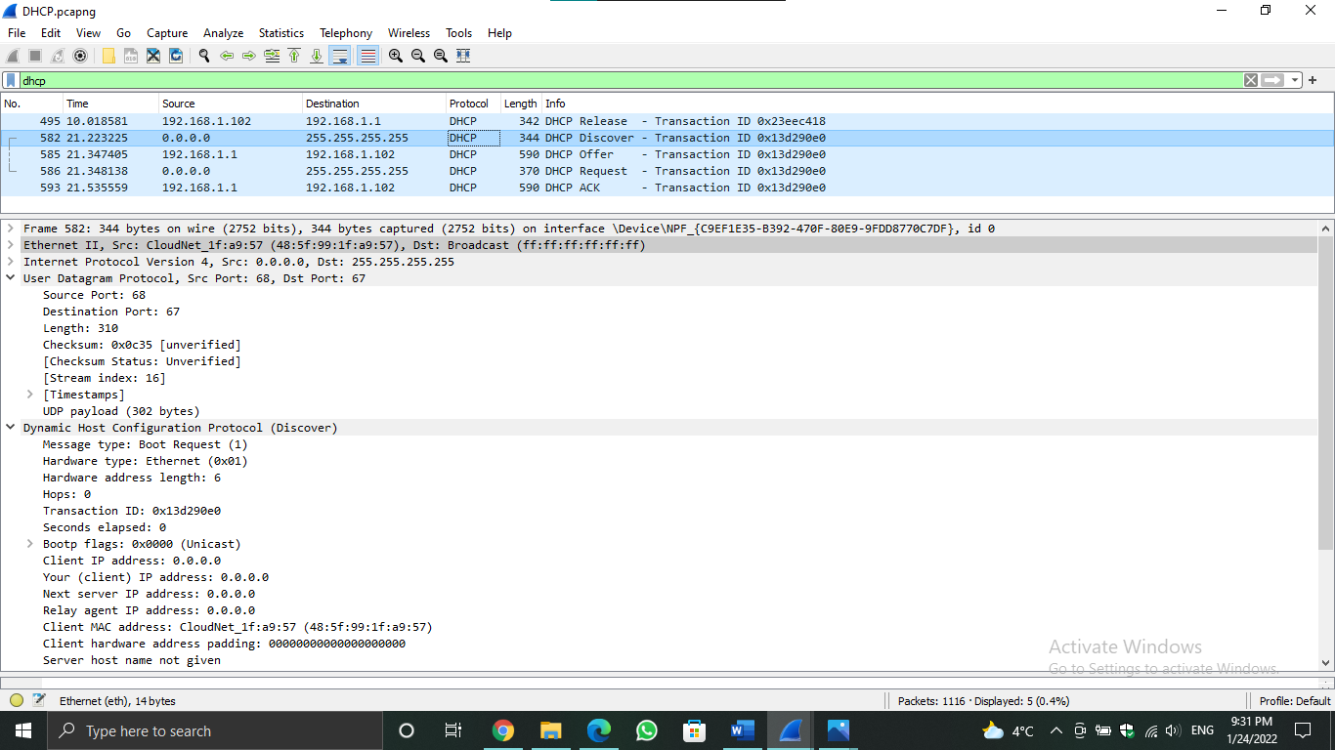

Figure 1.6

The next step is after configuring ipconfig /renew so the discovery for a DHCP server was started, as shown in figure 1.6.

* Message type: boot request (1)
* Hardware type: Ethernet, data link layer
* Hardware address length: 6
* Hops: 0, the number of hops which the DHCP packet can travel before being discarded

The following figure shows that the DHCP server responds with an offer for the client so the client IP address = 192.168.1.102

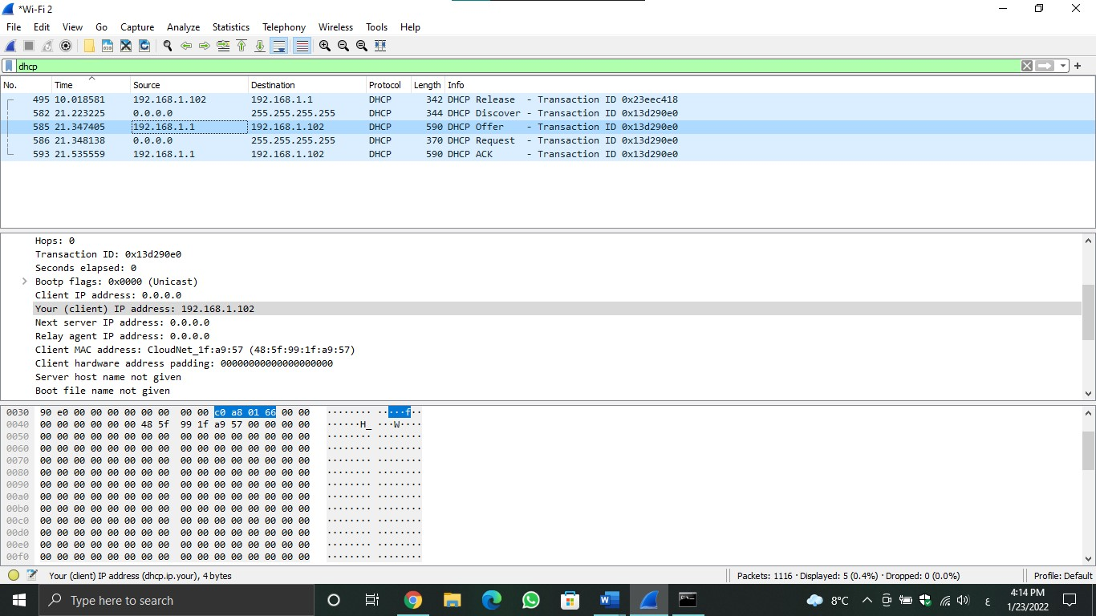

Figure 1.7

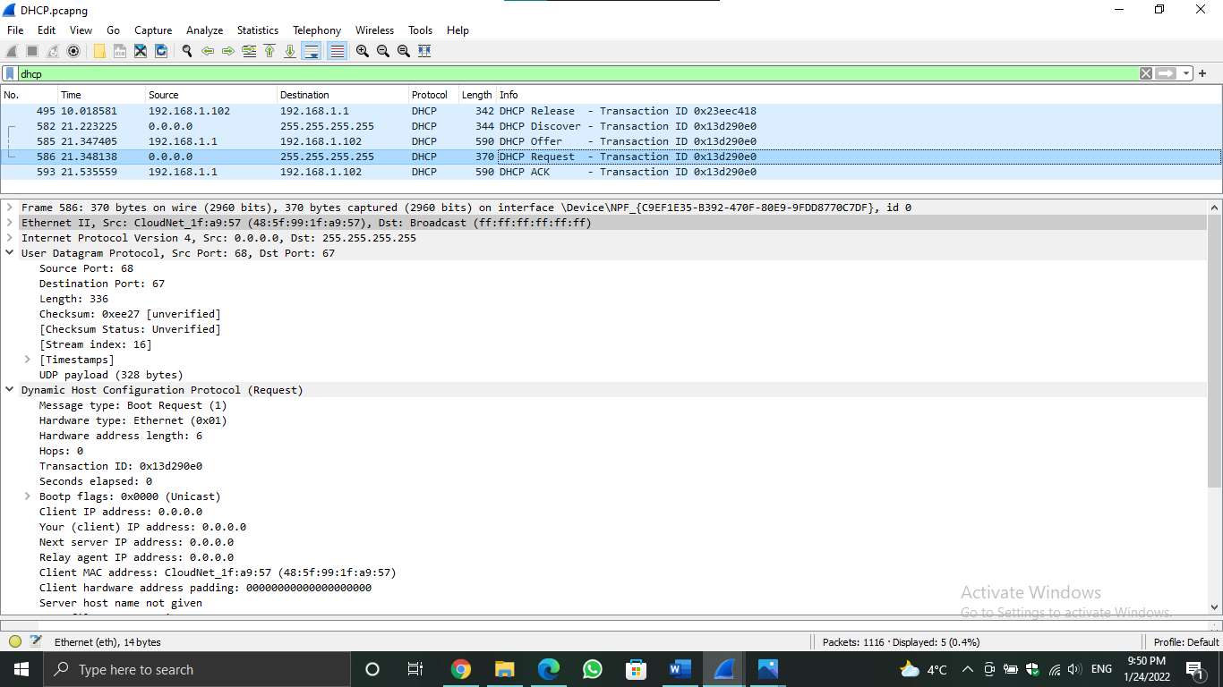figure 1.8

In figure 1.8 we notice that the IP address for the client is 0.0.0.0, it’s a client request to a server to get an IP.

* Message type: boot request (1) //it’s a boot request because the client is sending request signals
* Hardware type: Ethernet, data link layer
* Hardware address length: 6
* Hops: 0, the number of hops which the DHCP packet can travel before being discarded

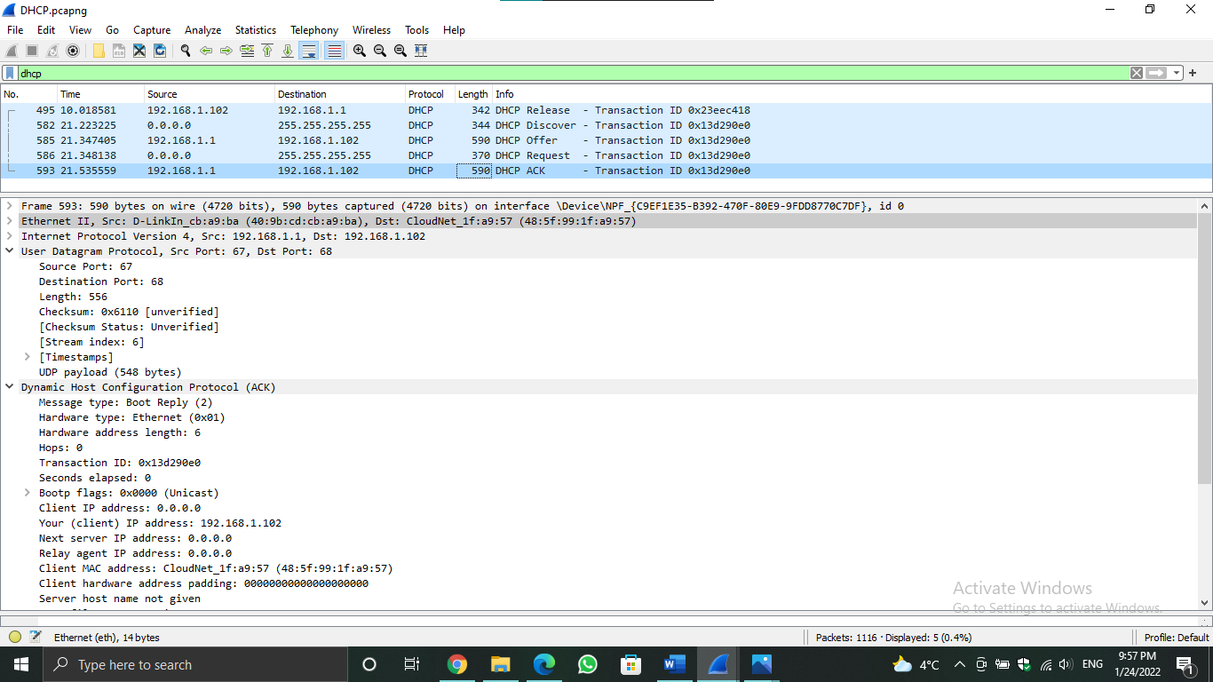

Figure 1.9

In figure 1.9, we notice the client has got an IP address.

* Message type: boot reply (2) //it’s a boot reply because the server is responding to the client
* Hardware type: Ethernet, data link layer
* Hardware address length: 6
* Hops: 0, the number of hops which the DHCP packet can travel before being discarded

Finally, ipconfig /all was configured in the cmd screen and the results are shown in the figure 1.10

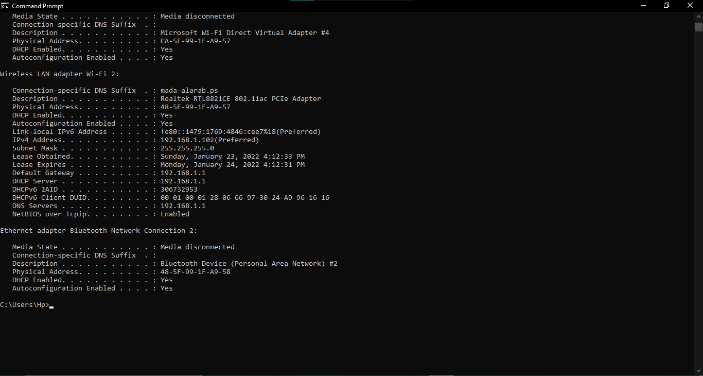

Figure 1.10

* ICMP
* **Definition**: internet control message protocol, is an error reporting protocol and provides services such as trouble-shooting. Unlike the DHCP packets, ICMP packets don’t have any source or destination packets because It’s a layer 3 protocol (network layer) so it is designed to communicate network information between hosts and routers.
* **Process**:
* The user/host signs an echo request to the server
* The server responds with echo reply packets.
* **Problem:** the attackers/hackers can use the ICMP replied packets to overwhelm the server, they prevent users to access a particular network by making it inaccessible.
* **In this part we will use Ping and tracert commands:**
* **Ping command:** is the primary TCP/IP command used to troubleshoot connectivity, reachability, and name resolution. Used without parameters, this command displays Help content.
* **The Traceroute command (tracert):** is a utility designed for displaying the time it takes for a packet of information to travel between a local computer and a destination IP address or domain.

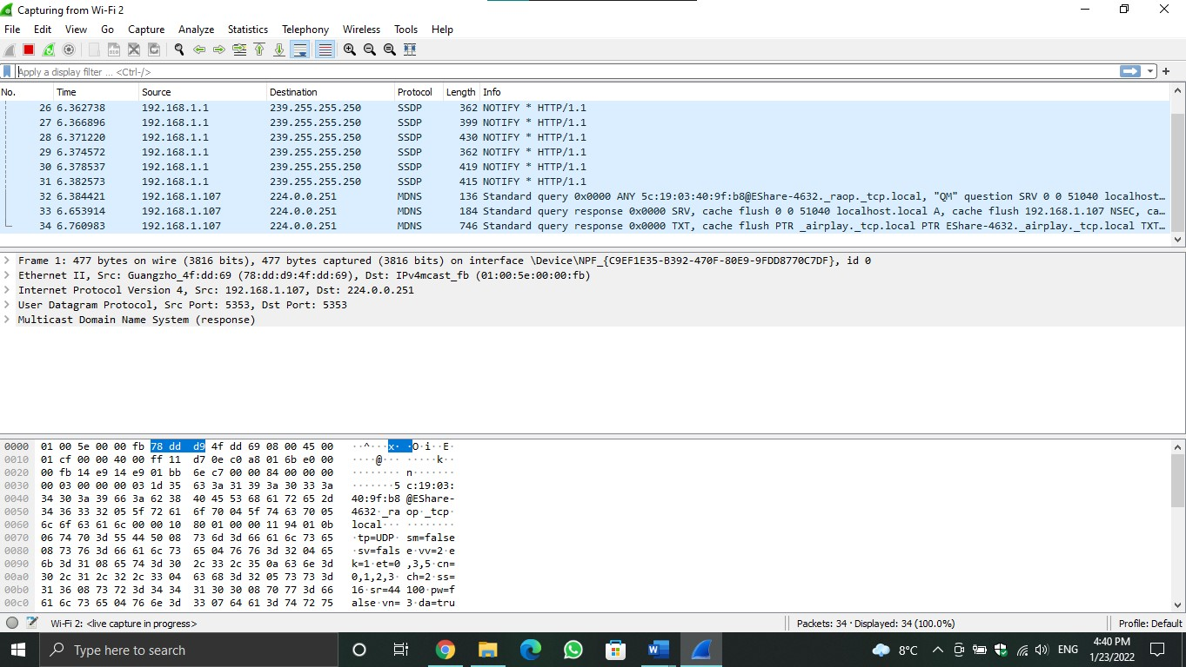

Figure 1.11

* **Figure 1.11 shows that the computer started capturing by itself.**

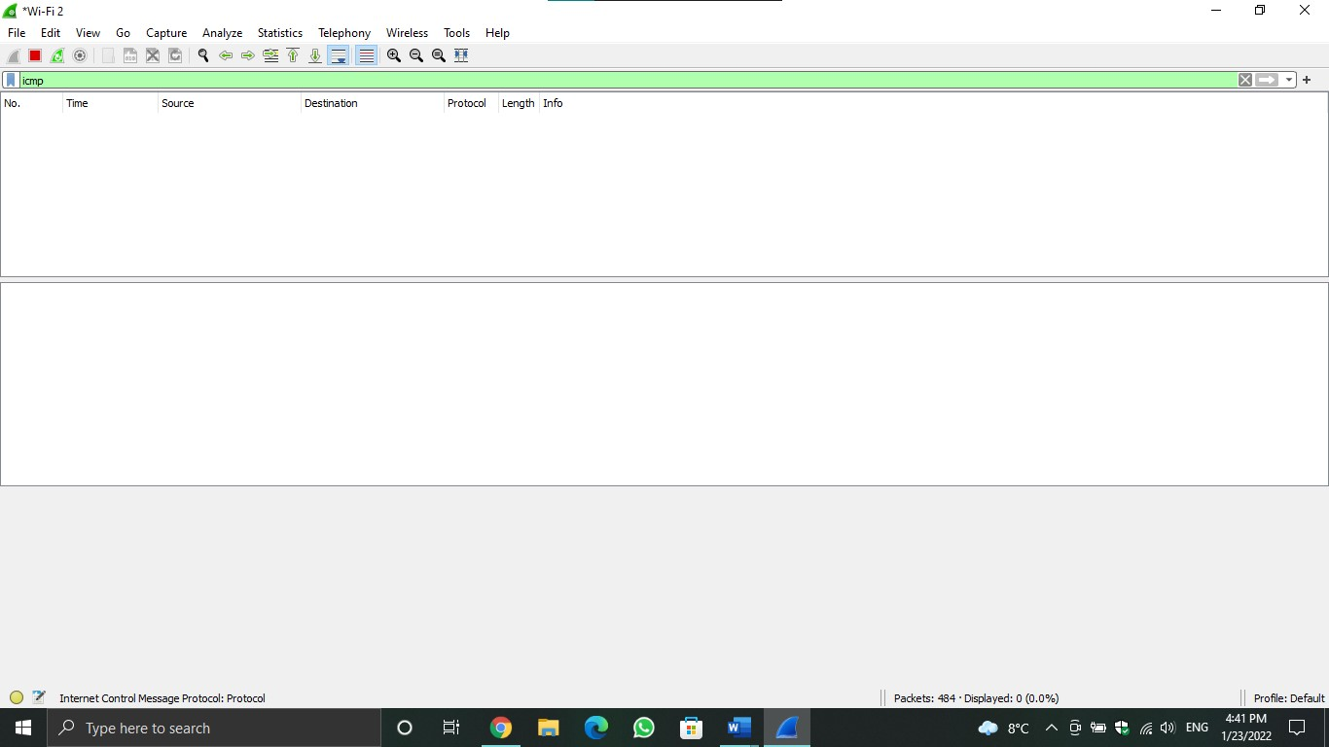

Figure 1.12

* **In figure 1.12, we notice that there are no packets for ICMP, and that’s because we haven’t pinged any website yet.**

**In the following figure, the ritaj.edu site which has a 104.22.8.107 IP address was pinged, and the ICMP packets requests and replies appeared as shown in figure 1.13**

**Also, we pinged youtube.com and Cambridge university site to check the ICMP packets**

**In figure 1.13, we notice that the destination IP for the first packet is equal to the IP address for ritaj site, so that means the client is sending requests to ritaj.**

**For the first packet, the sequence number is 1/256, the time to live is 128 ms.**

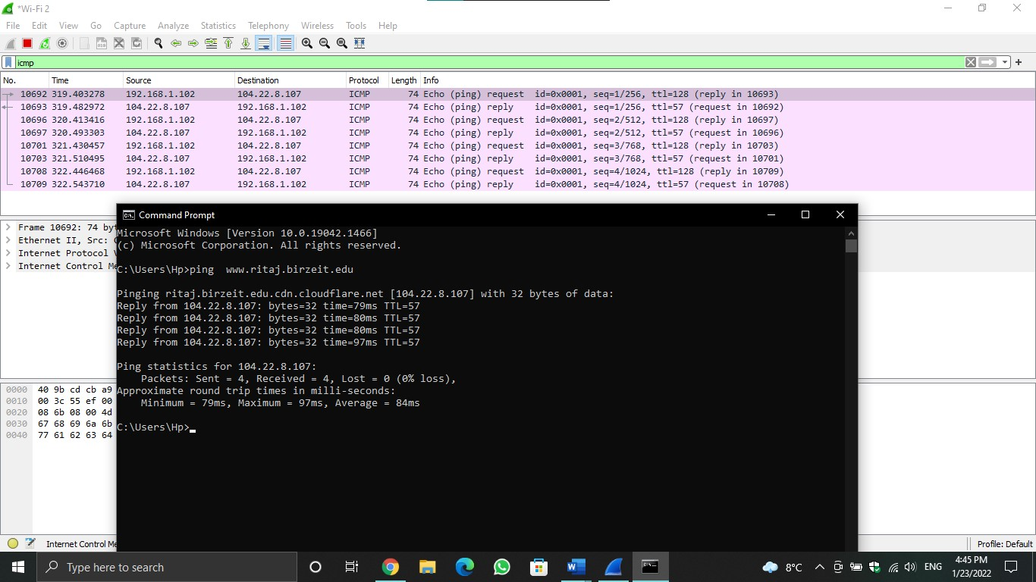figure 1.13

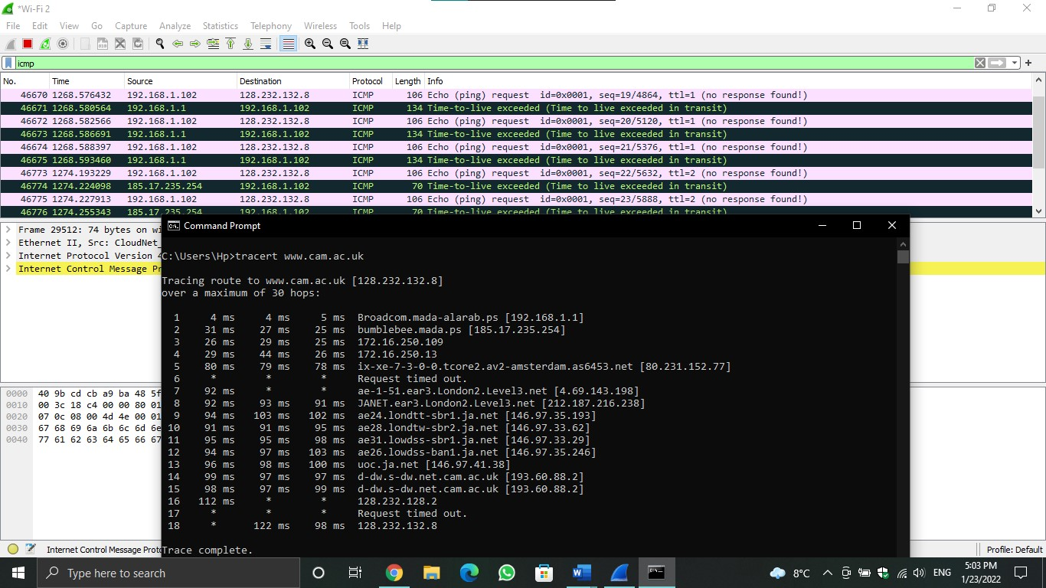

figure 1.14

Here in figure 1.14, we traced [www.cam.ac.uk](http://www.cam.ac.uk) site and the results are shown below in figure 1.15

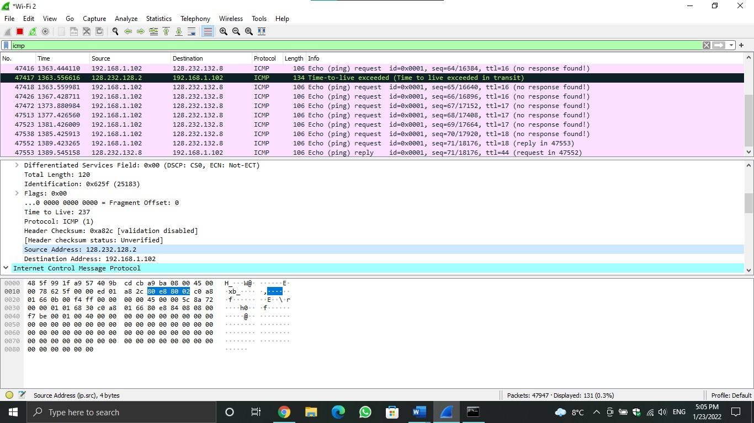figure 1.15

* 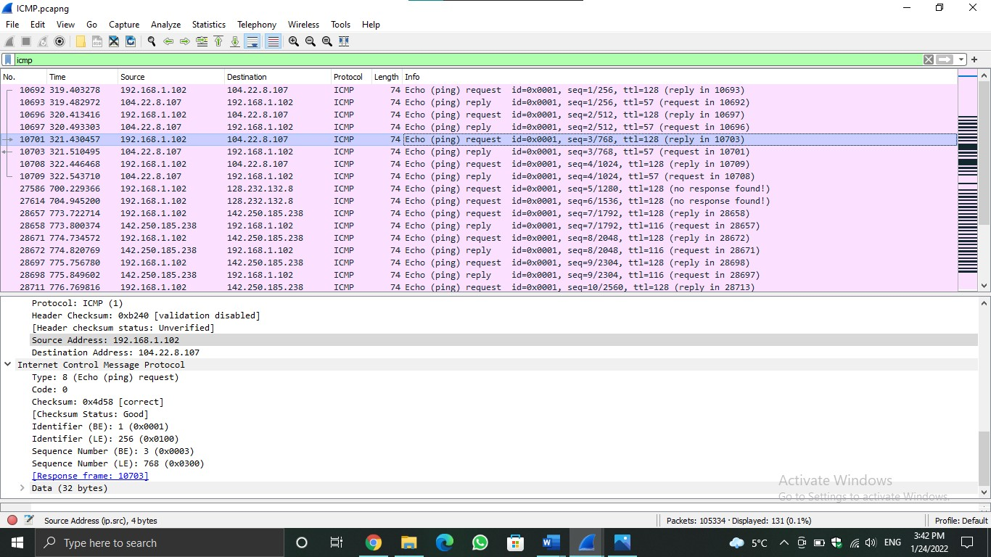NO RESPONSE FOUND, this result means that the website we searched for doesn’t send and replied packets, they stop ICMP packets from entering their network and that’s because of their security.

Figure 1.16

Here in figure 1.16, the fields of a packet are shown.

* Some definitions for the ICMP packet fields:

- Type: it’s a way of making the receiver knows the type of the message, for example, if the type was = 8, that means it’s a request message, so the receiver should send echo type 0 as a reply to the requested message

- Code: it represents the message type code that provides additional information about the error type. It’s always = 0 for ICMP packets

- The identifier and sequence number may be used by the echo sender to aid in matching the replies with the echo requests. For example, the identifier might be used as a port in TCP or UDP to identify a session, and the sequence number might be incremented on each echo request sent.

* In the packet in line 10701:
* The source IP address: 192.168.1.102 (it’s my computer’s IP)
* The destination IP address: 104.22.8.107 (it’s ritaj’s IP)
* Type: 8 (request message)
* Code: 0
* Identifier (BE, big Endian): 1
* Identifier (LE, little Endian): 256
* Sequence Number (BE): 3
* Sequence Number (LE): 768
* TCP
* **Explanation about what have done in the TCP checking part:**
* After we opened the Wireshark program, it started capturing.
* The Ritaj website was searched via the browser, and then a zipped file was sent as a message, and then returned to the Wireshark app to see the various packets that were sent.
* We searched about TCP in the app search box.
* The packets were checked in which the destination address is the address of Ritaj (104.22.8.107)
* We noticed the sequence number, the acknowledgment, the window size, the length of the TCP segment, and the maximum segment size.
* As for the data size, its value was obtained by the following law: **“Total length – Header length”.**
* Note: The Header length is always equal to 20.

**Packet NO.1**

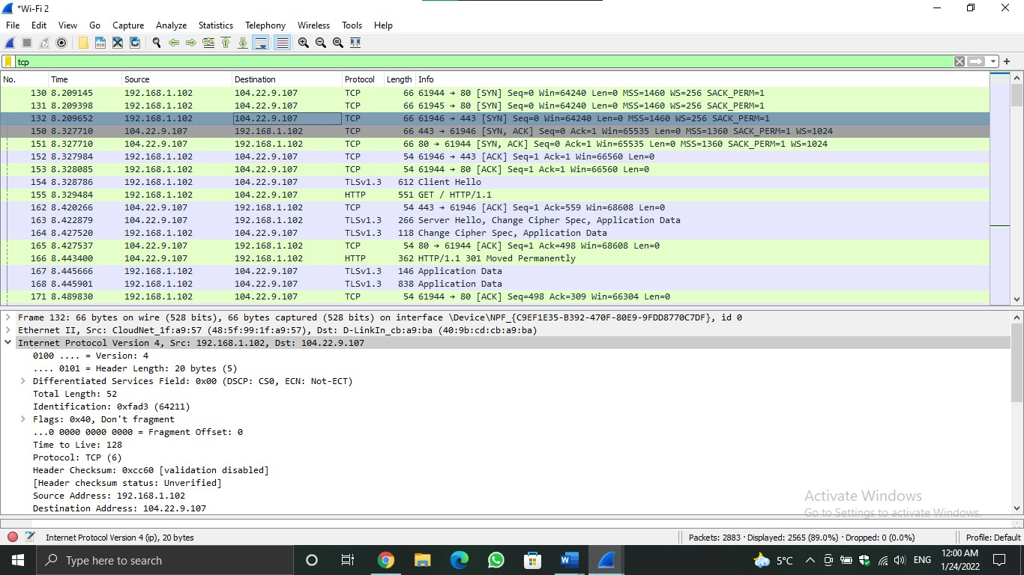

Figure 1.17a

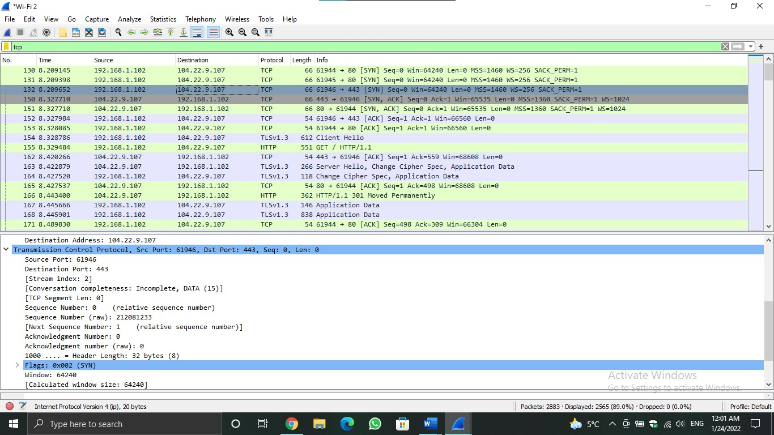figure 1.17b

**In figures 1.17a and 1.17b:**

* Sequence number: 0
* Acknowledgment number: 0
* Data size: total length – header length = 52 – 20 = 32.

**Packet NO.2**

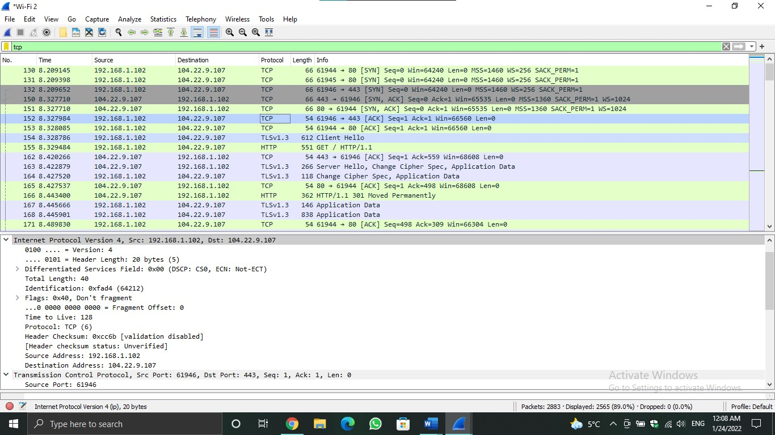figure 1.18a

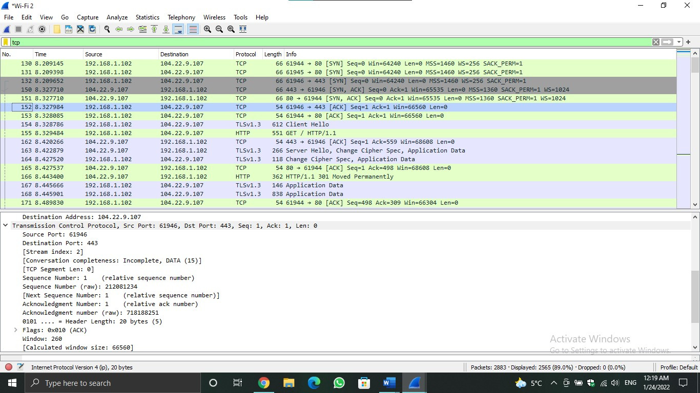

figure 1.18b

**In figures 1.18a and 1.18b:**

* Sequence number: 1
* Acknowledgment number: 1
* Data size: total length – header length = 40 – 20 = 20.

**Packet NO.3**

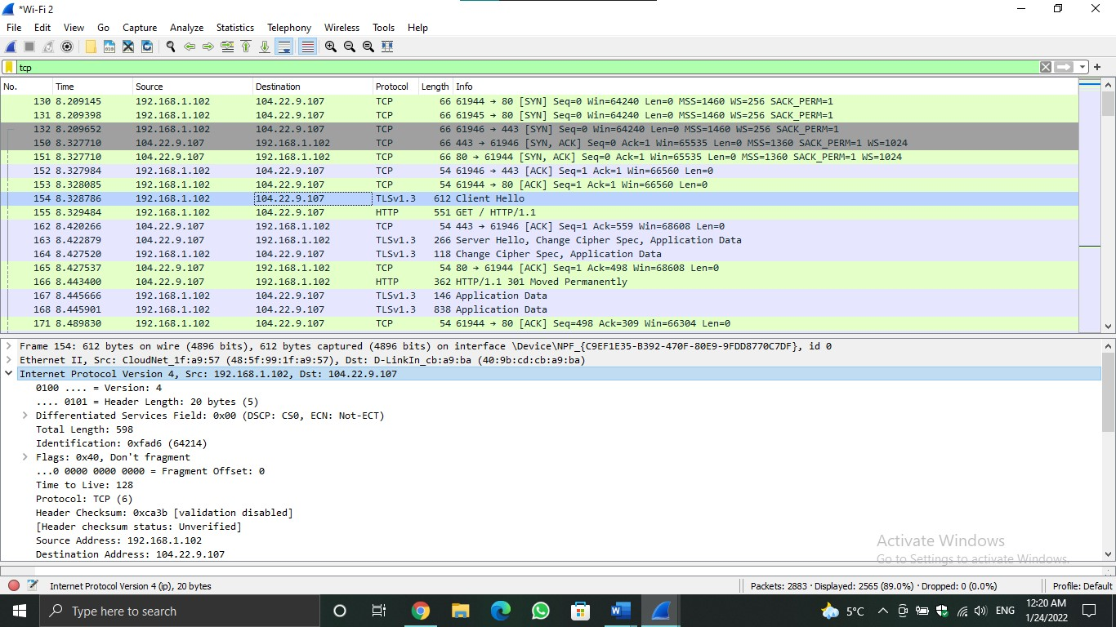

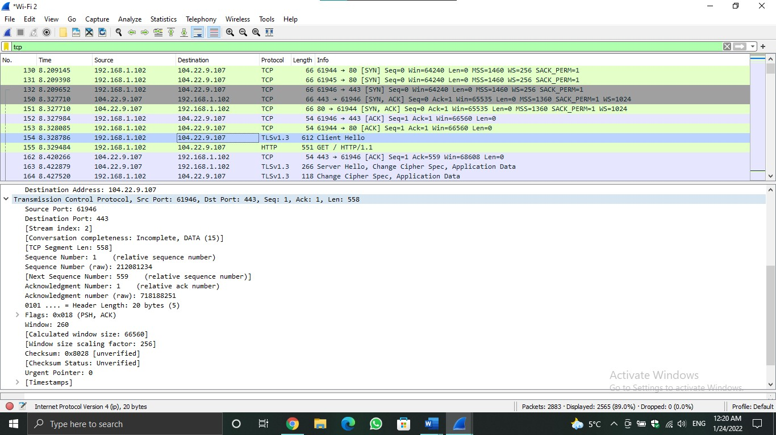Figure 1.19a

Figure 1.19b

**In figures 1.19a and 1.19b:**

* Sequence number: 1
* Acknowledgment number: 1
* Data size: total length – header length = 598 – 20 = 578.

# Part 2

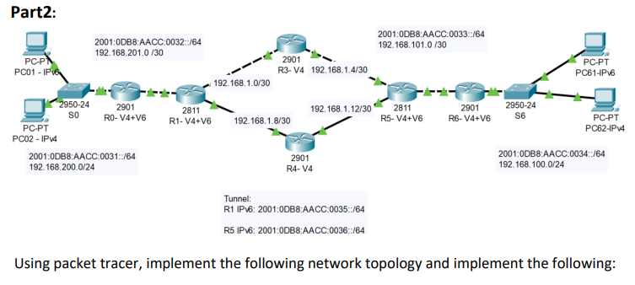

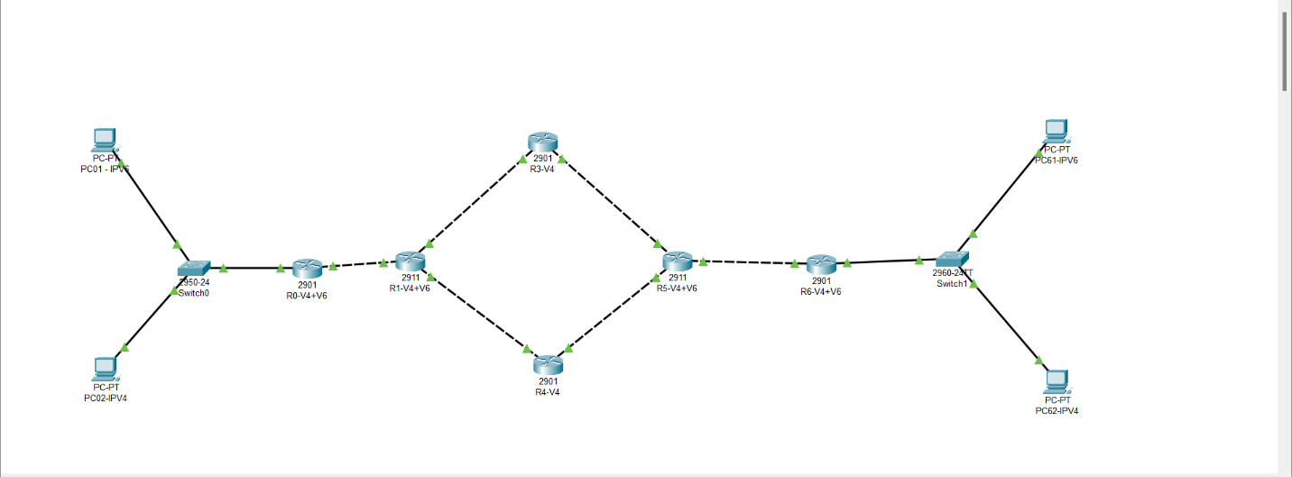

Figure 2.1

1. Assign IP addresses to all PCs:

* 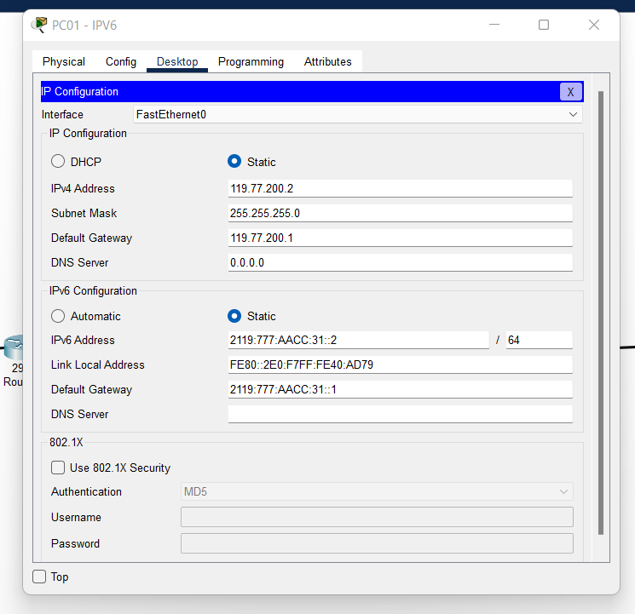PC01:
* PC02
* 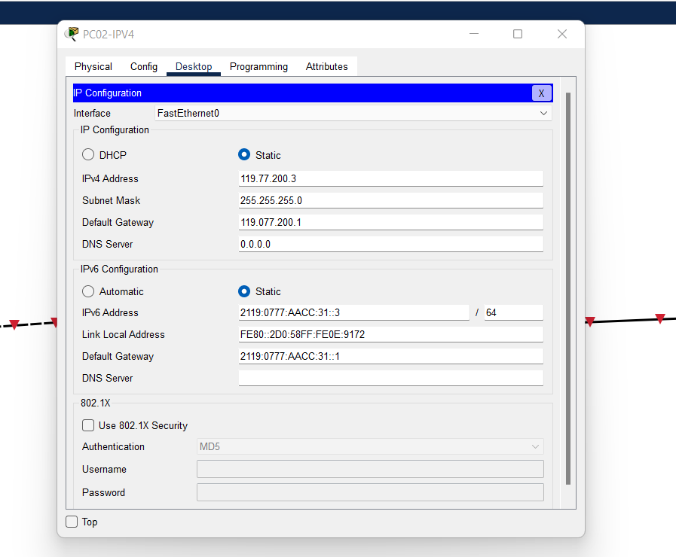PC61:
* 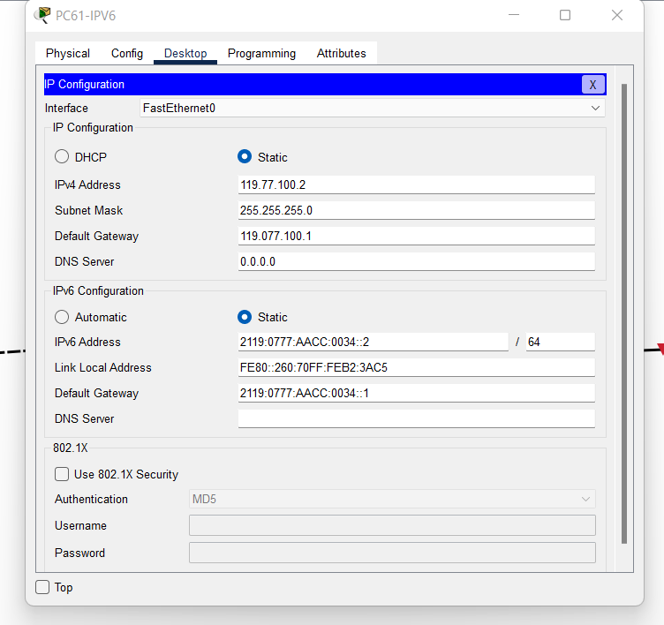PC62:

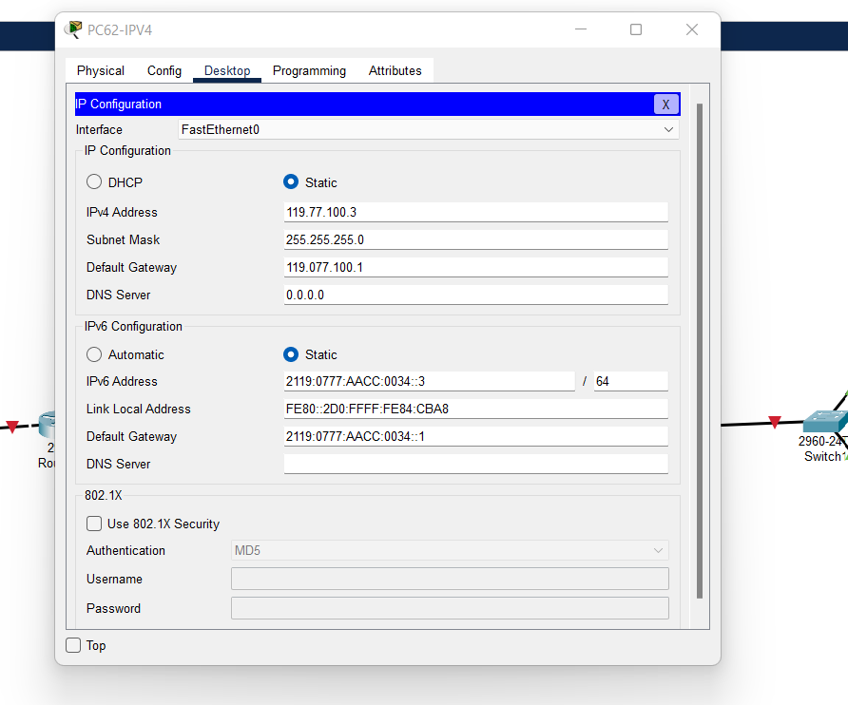

# 2. Assign IP addresses to all router interfaces following the criteria below.

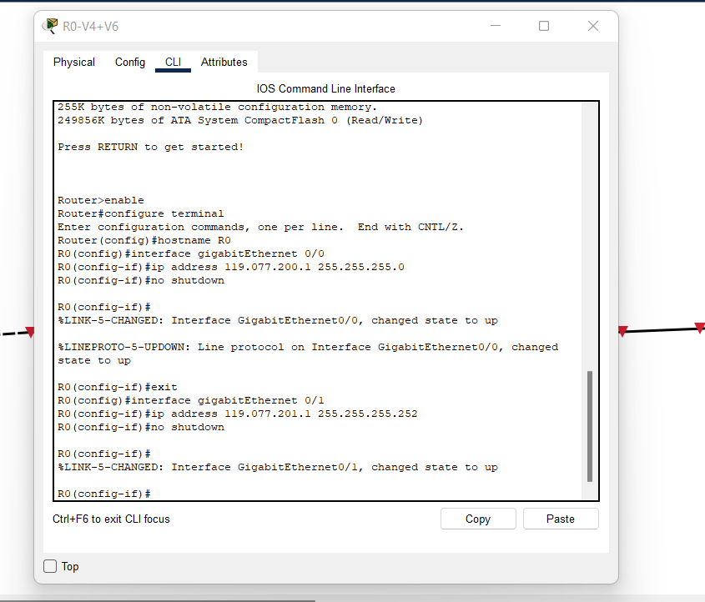

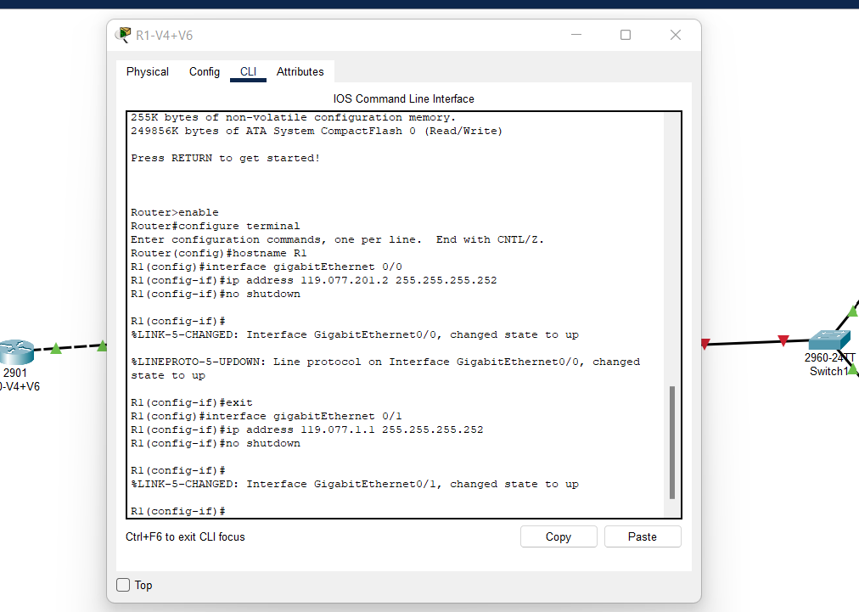

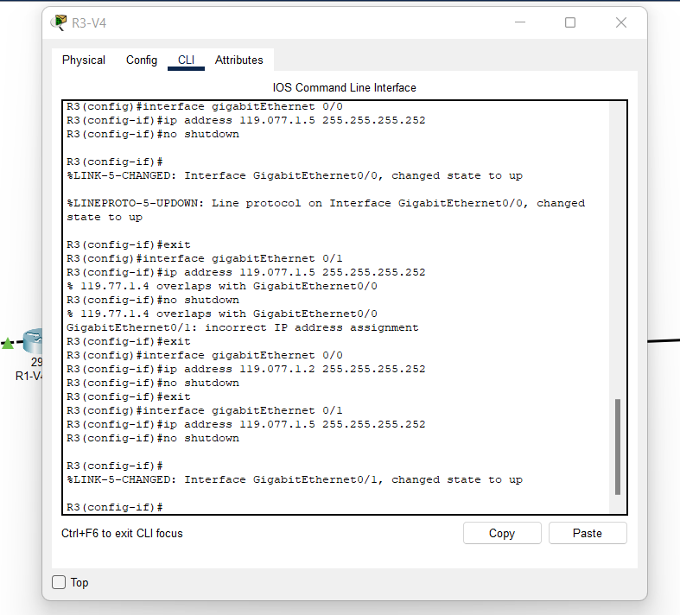

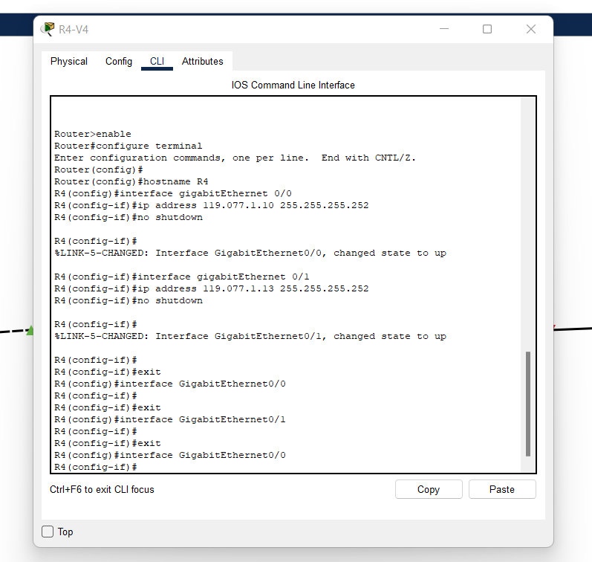

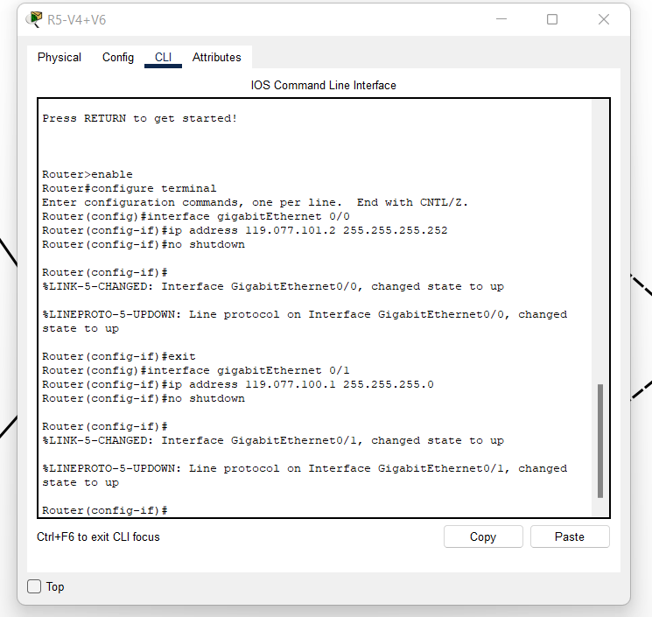

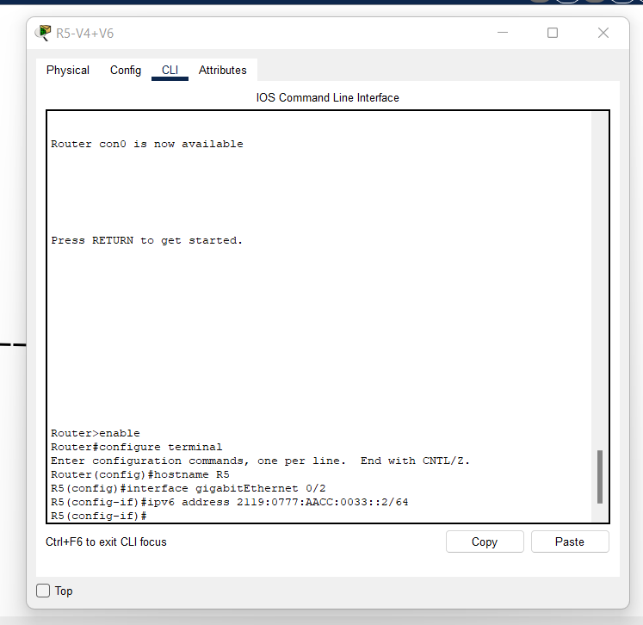

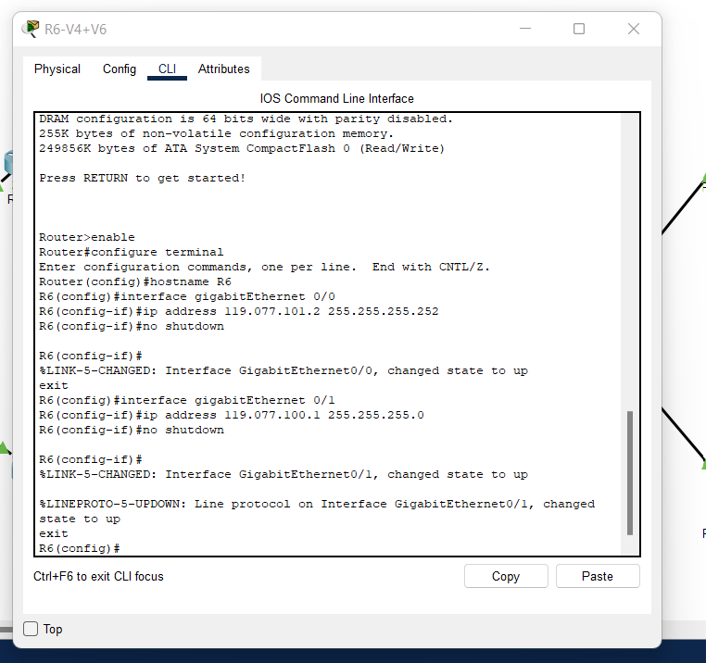

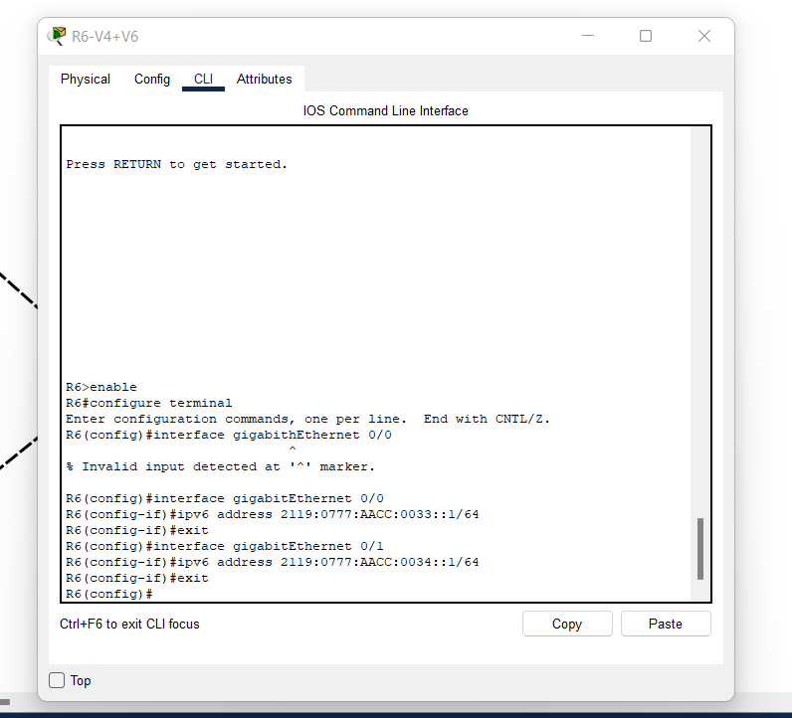

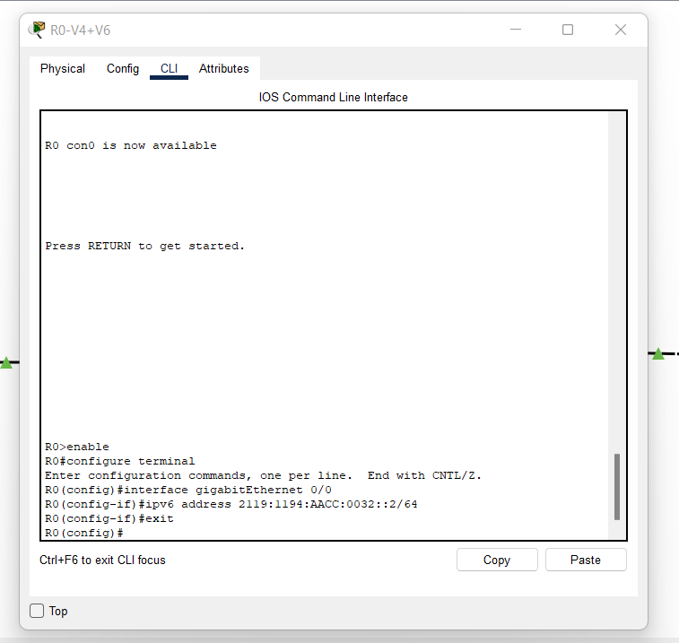

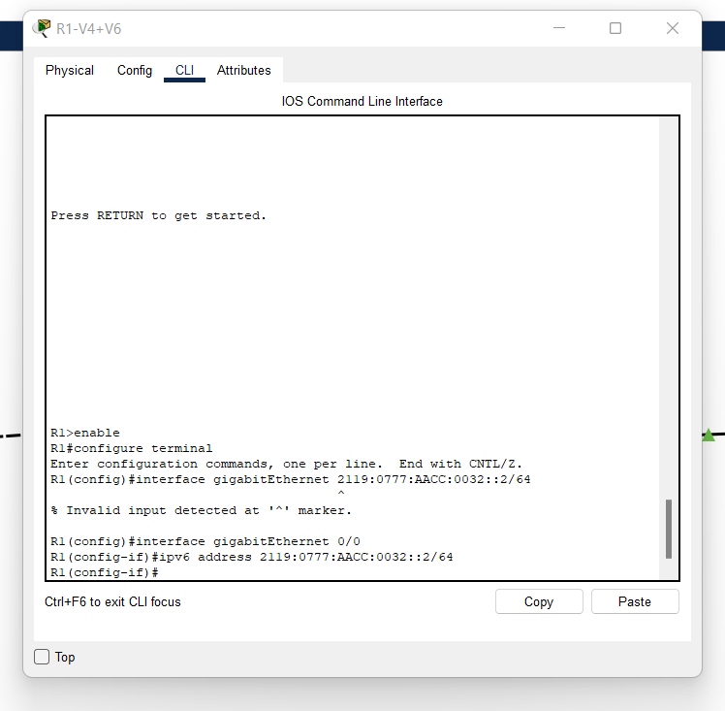

# 3. Make sure each host can ping at least one other host in the same network:

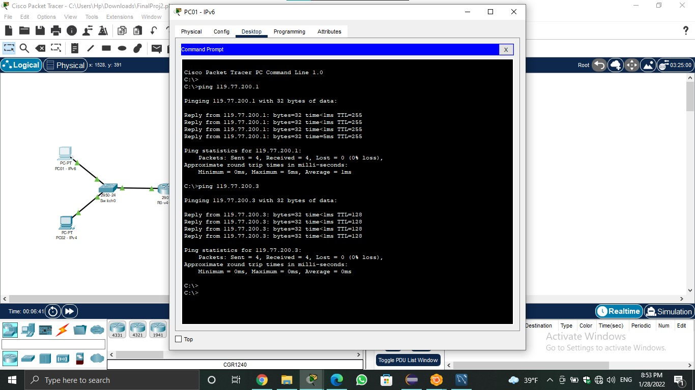

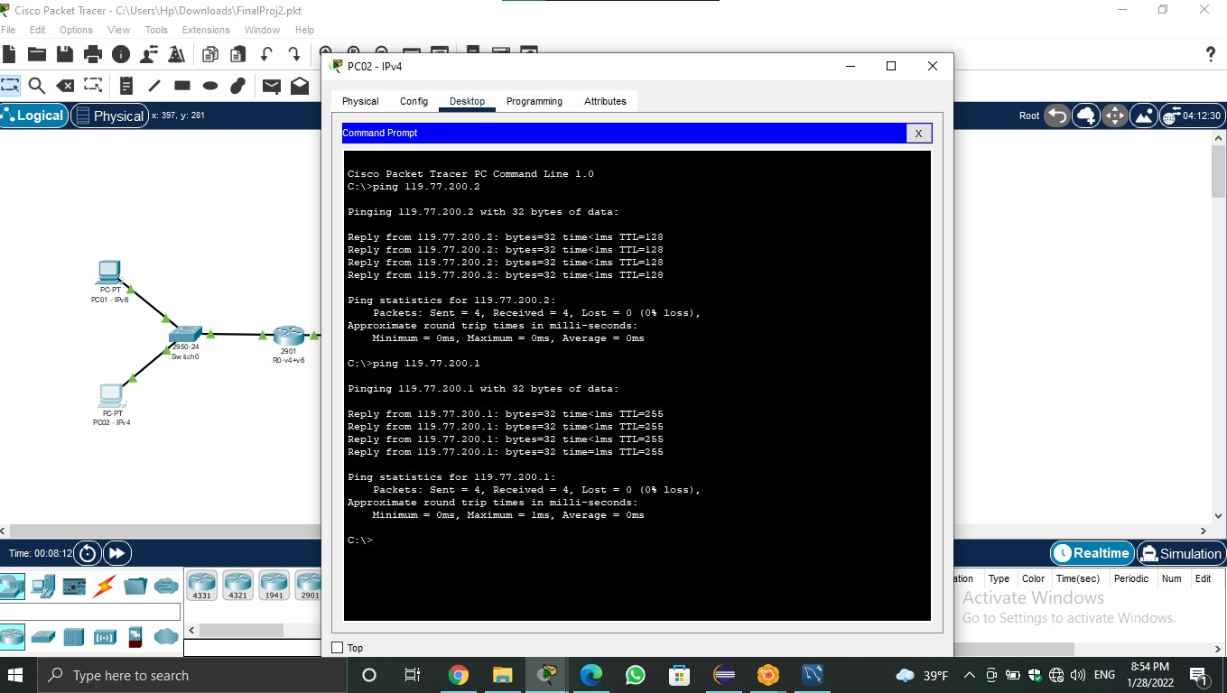

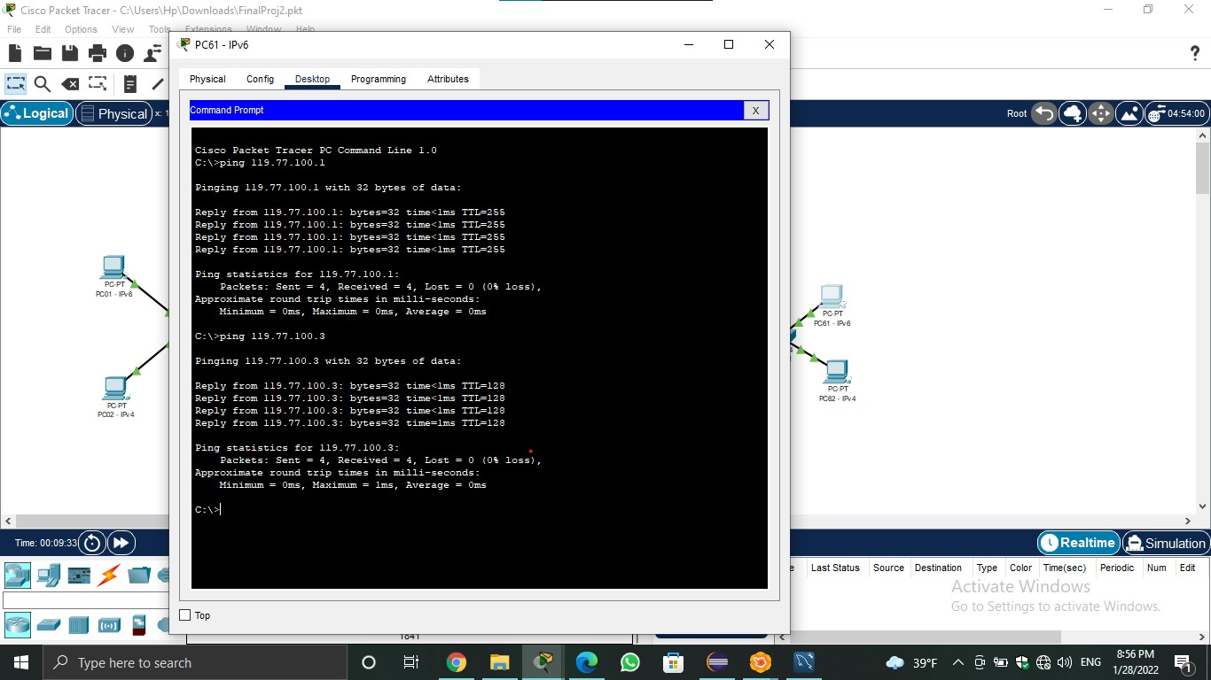

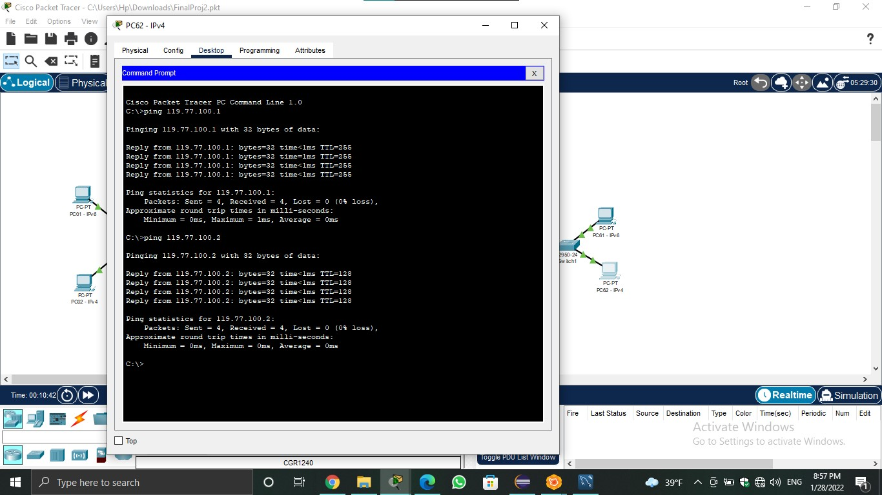

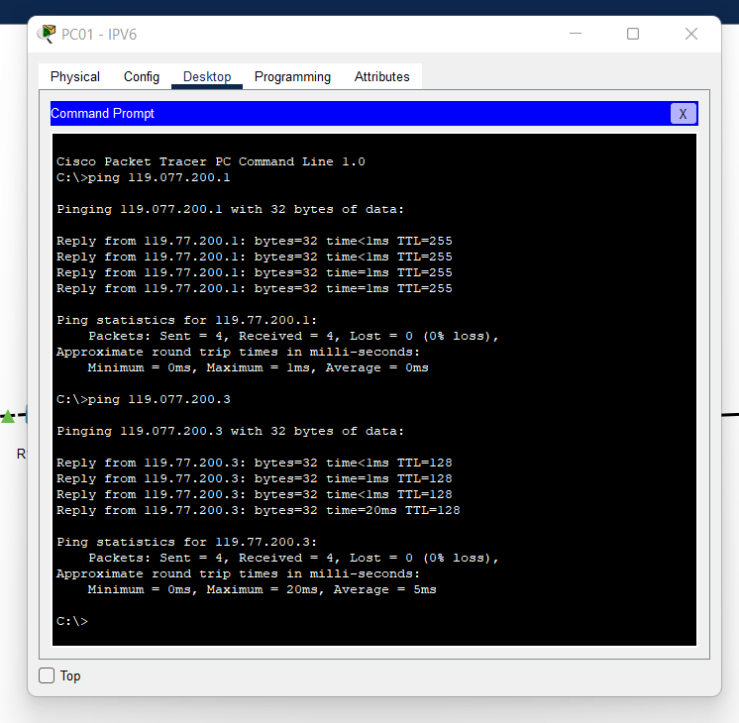

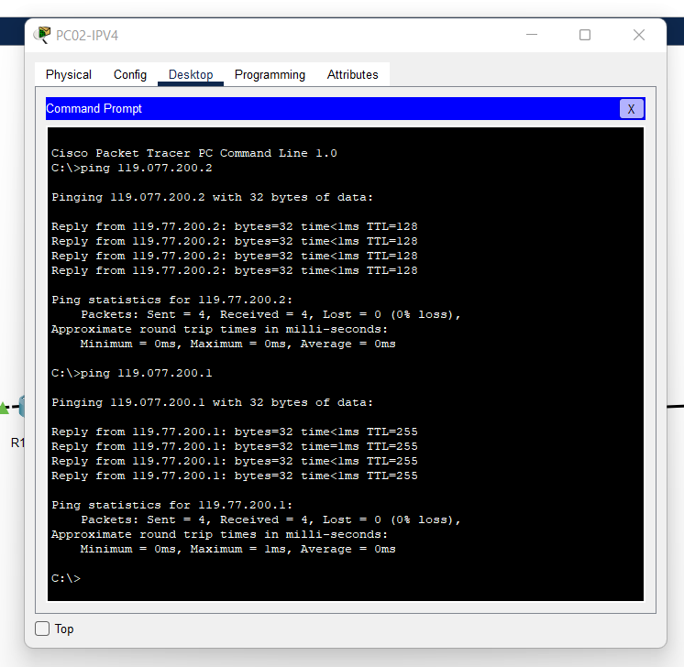

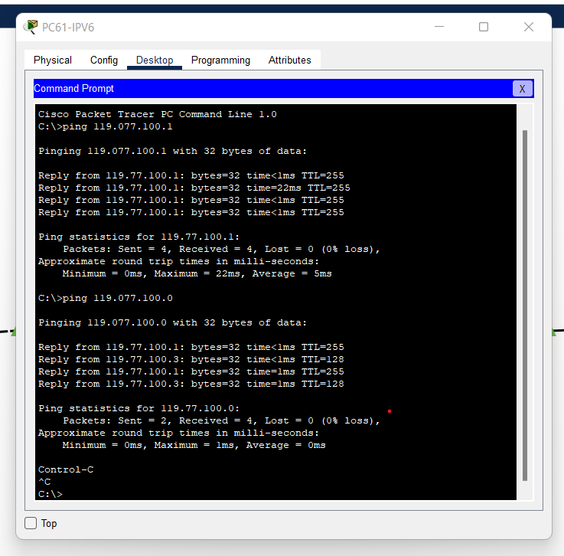

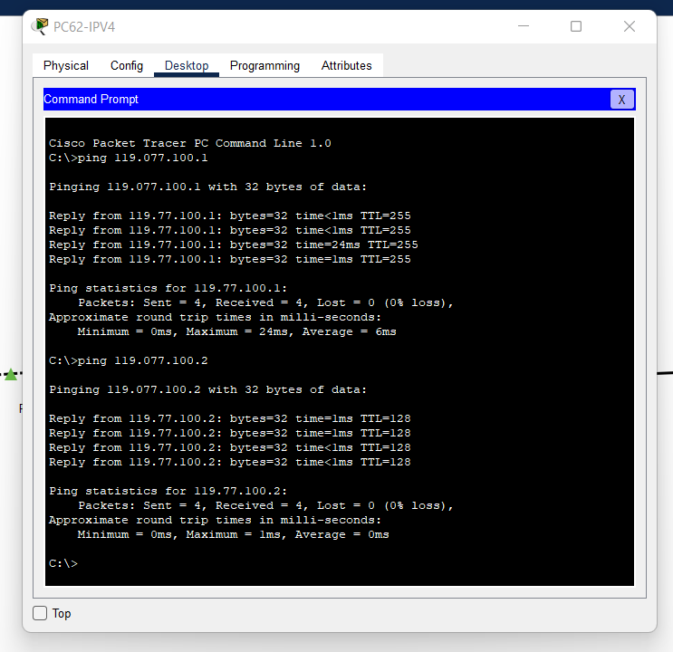

# 4. Implement single area OSPF routing protocol for IPv4:

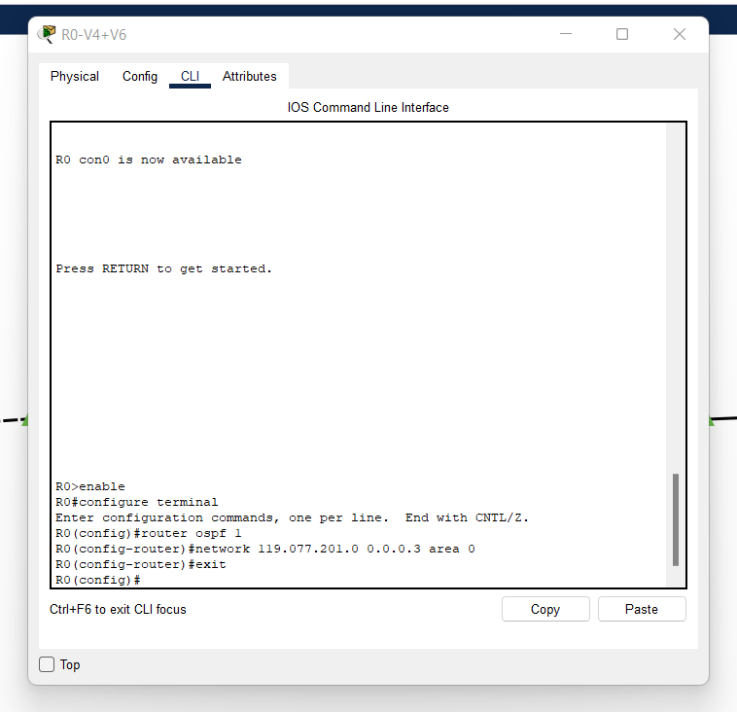

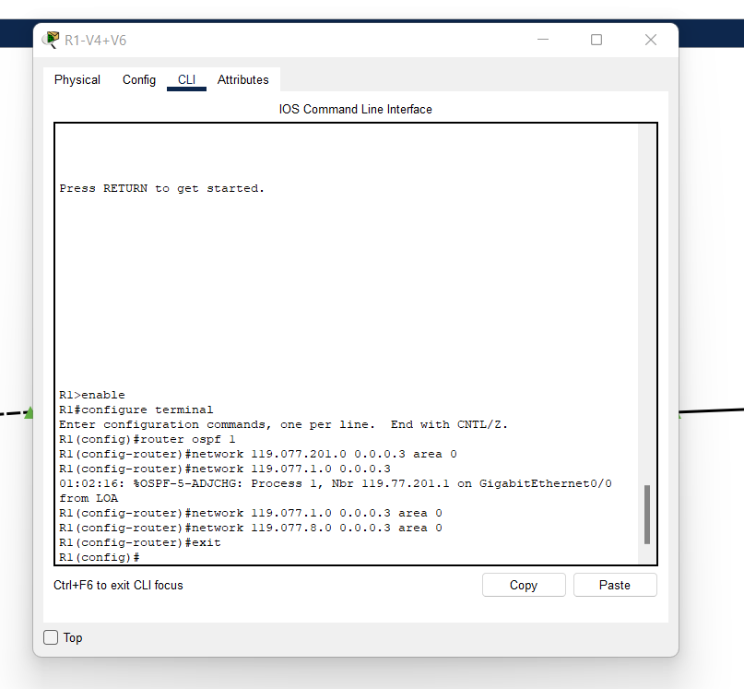

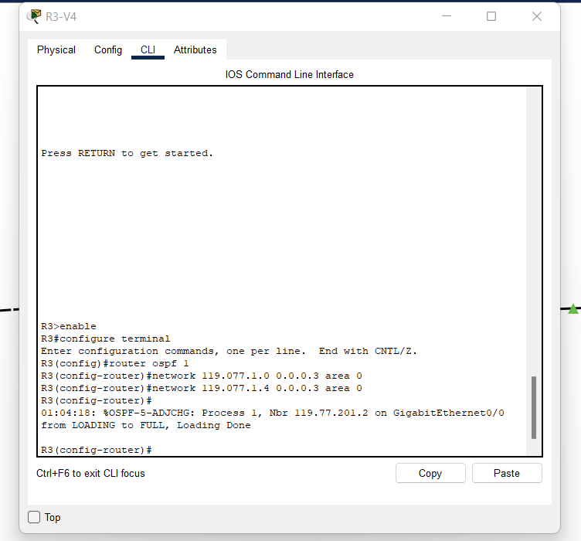

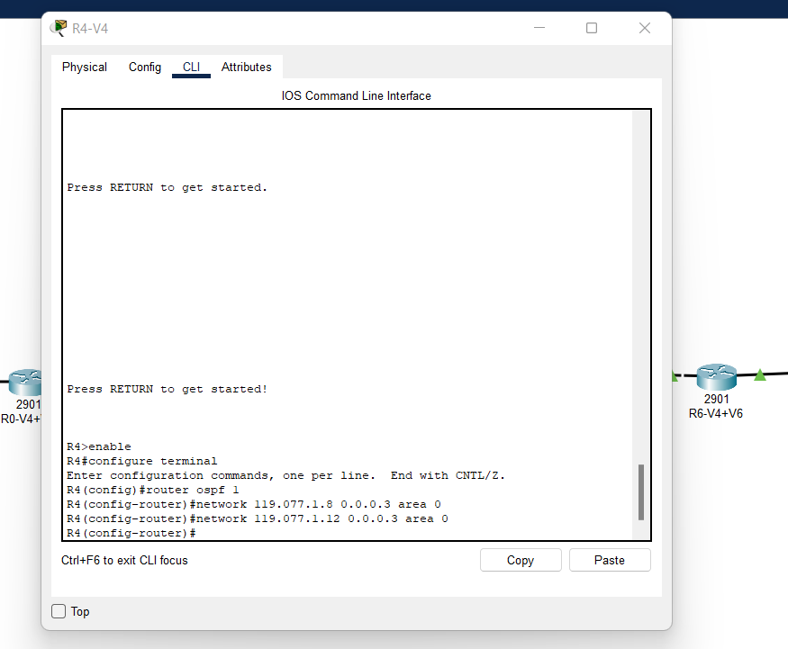

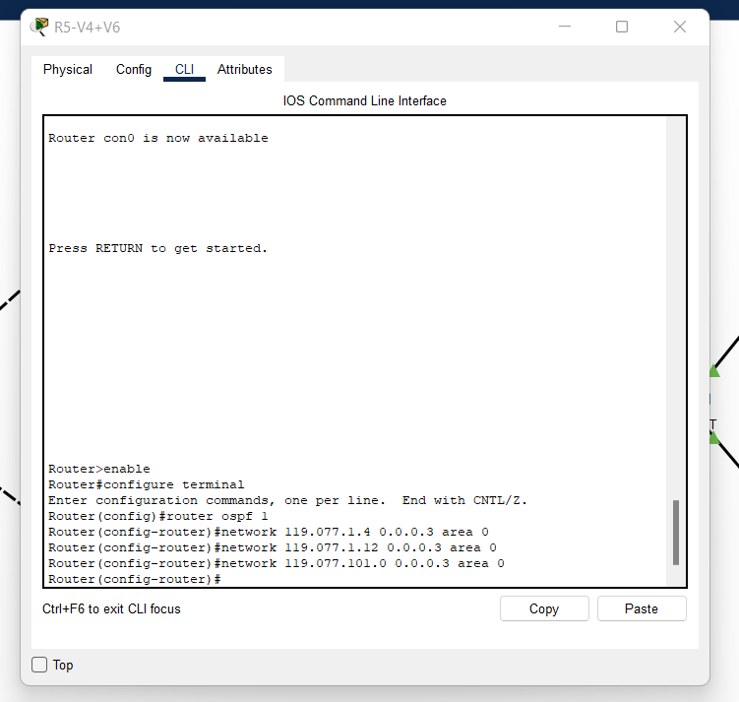

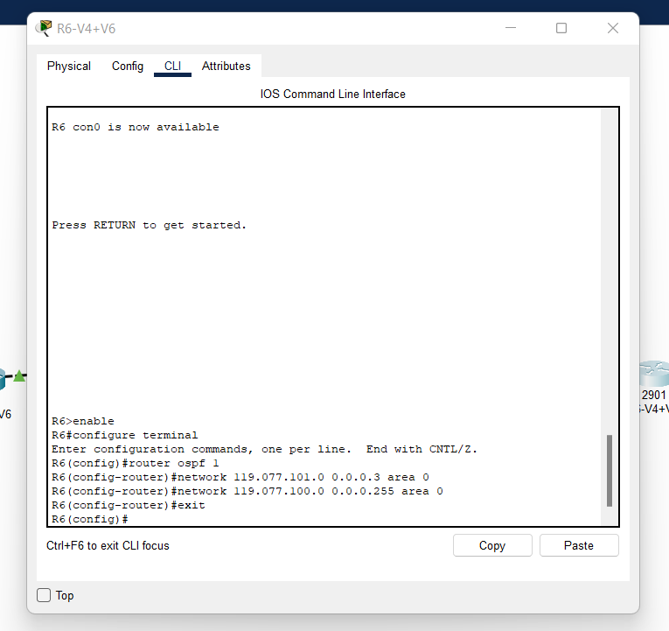

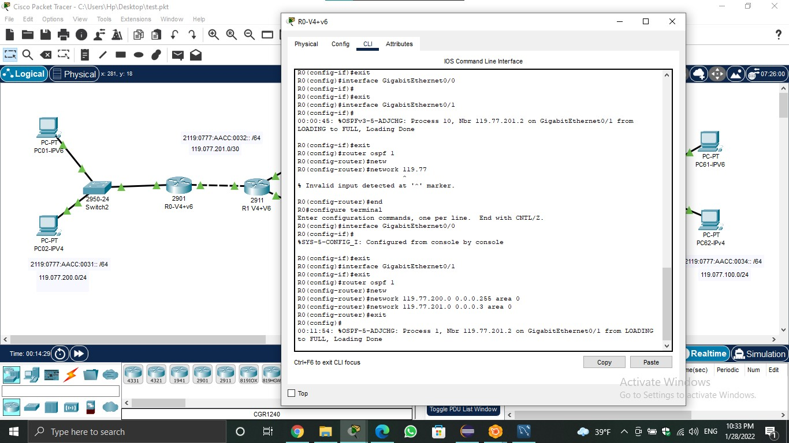

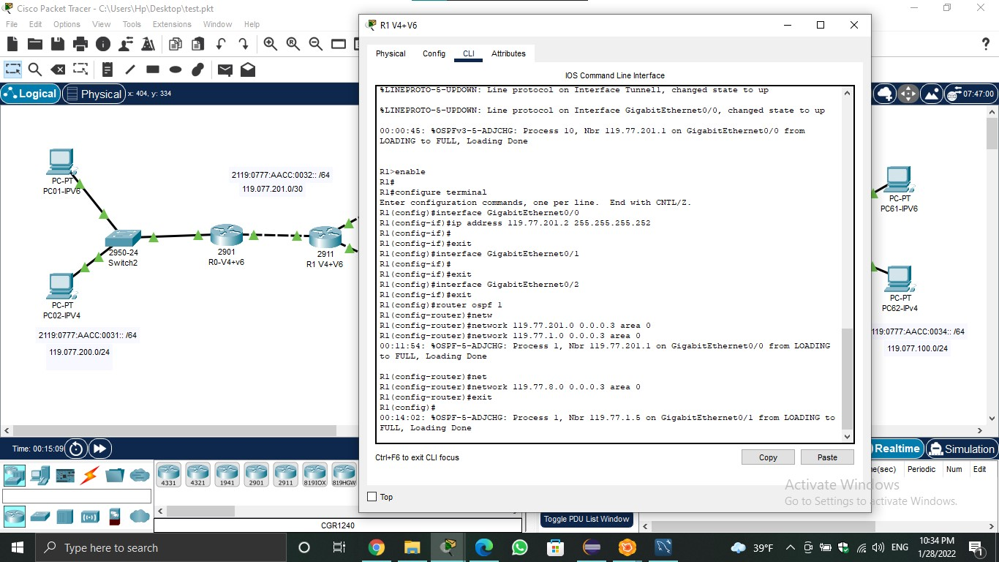

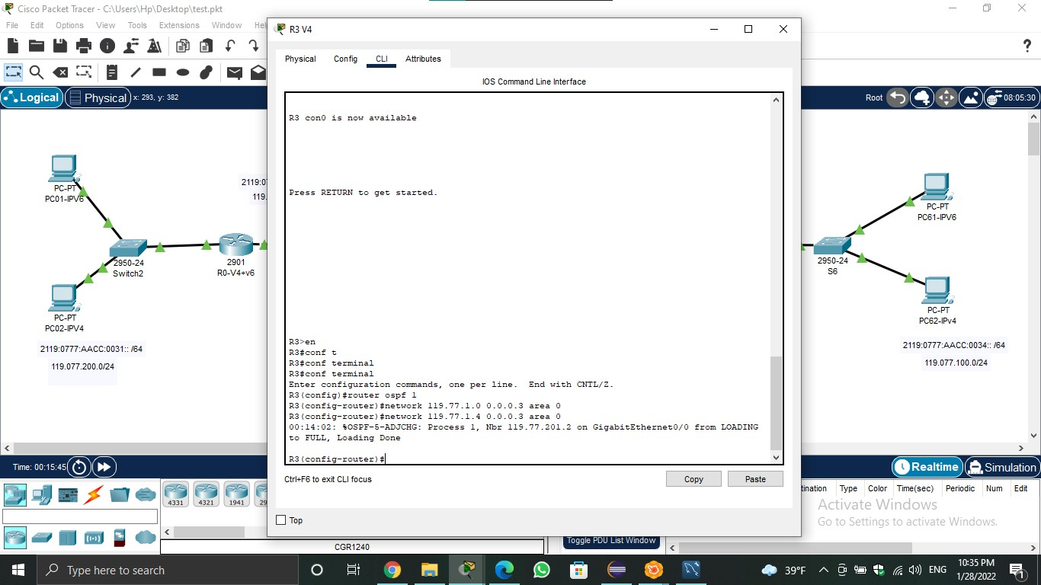

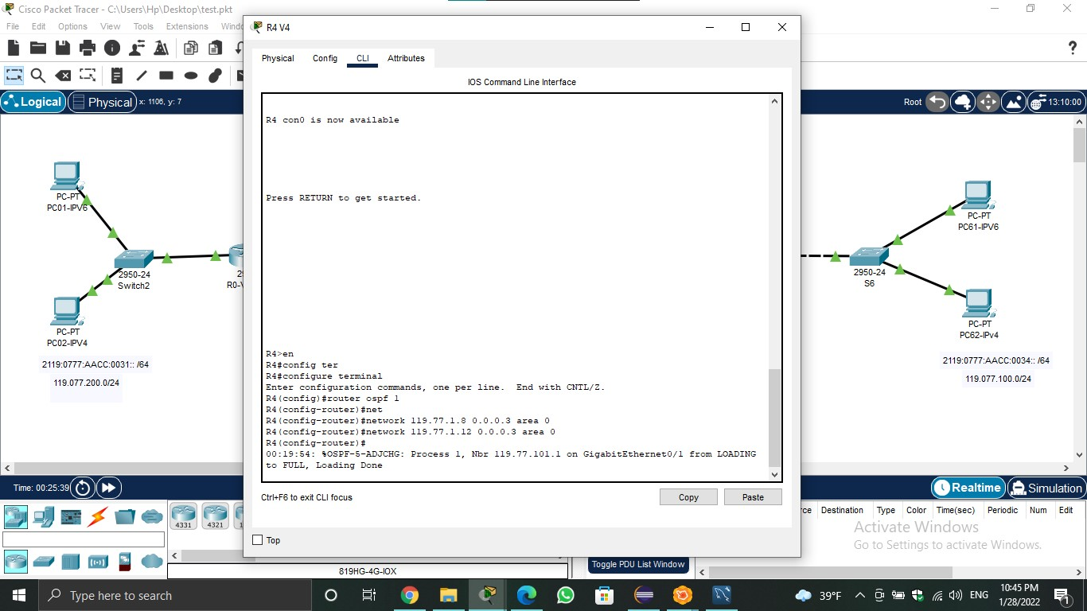

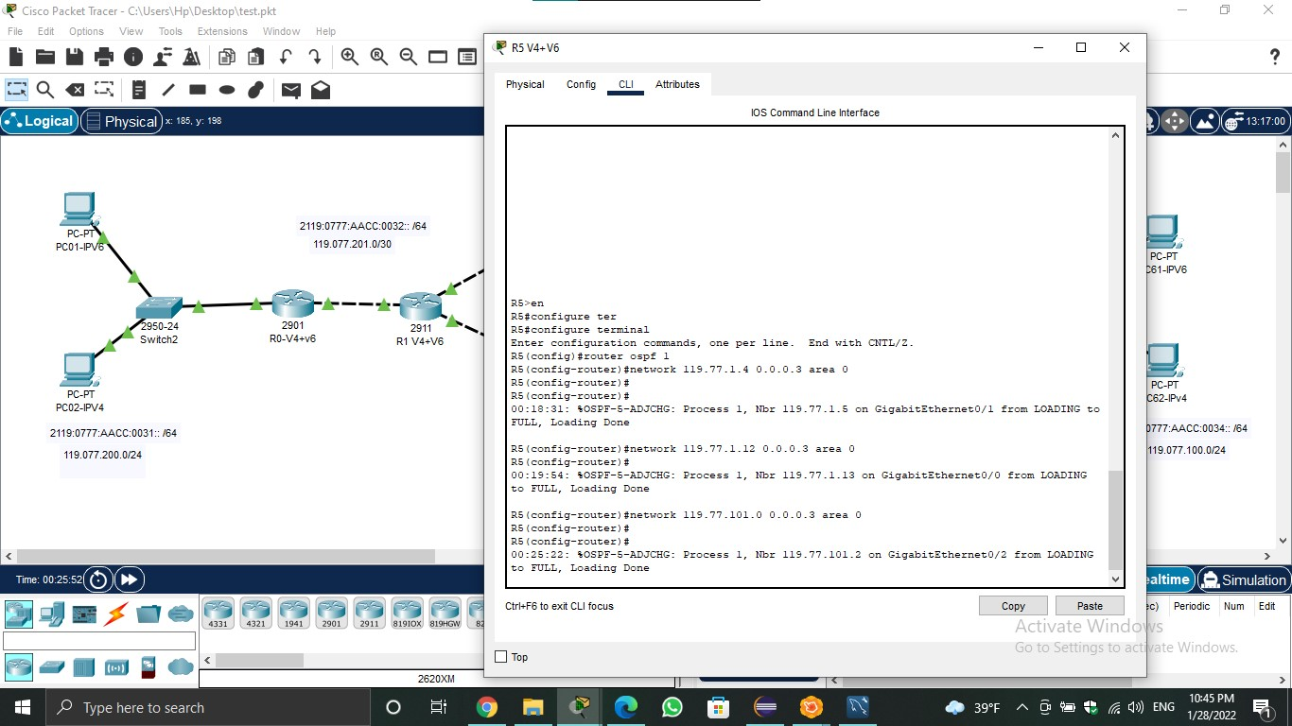

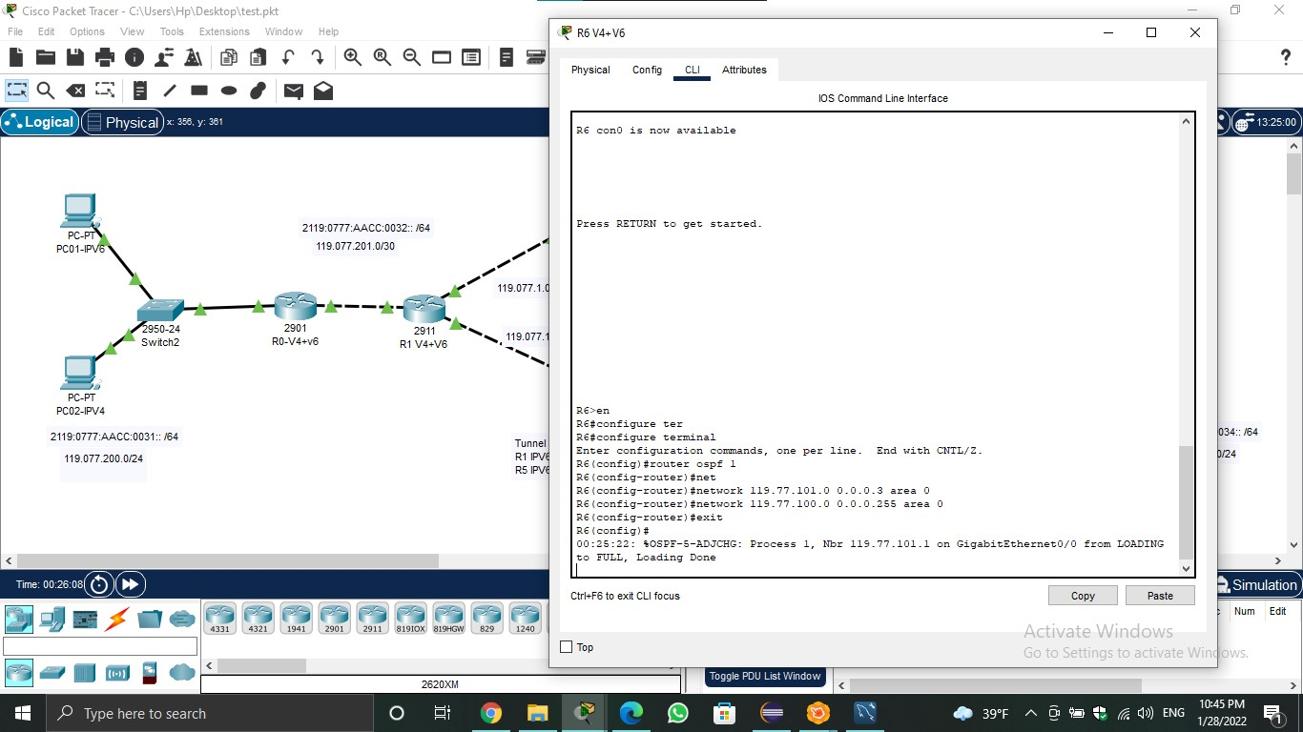

**Single area ospf using ipv6 for R0:**

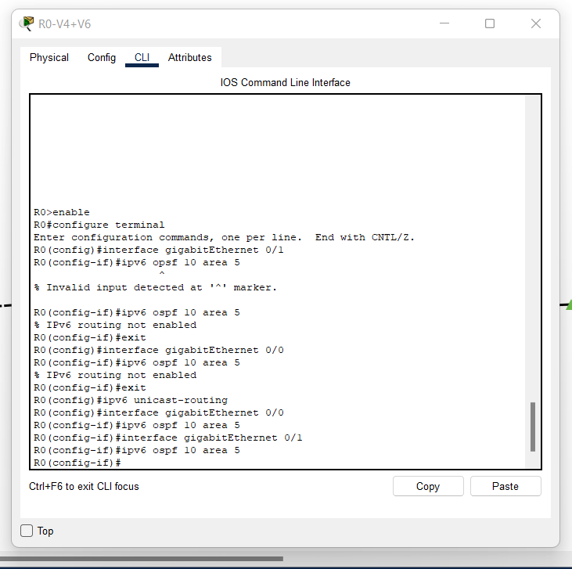

**Single area ospf using ipv6 for R1:**

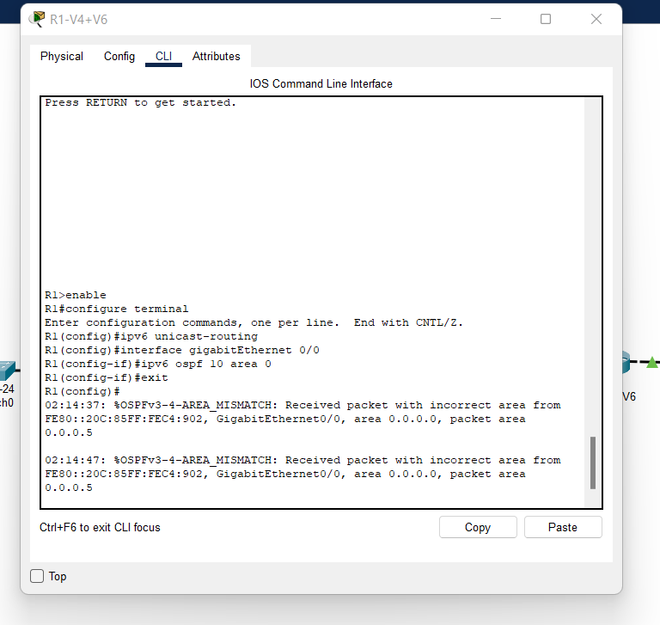

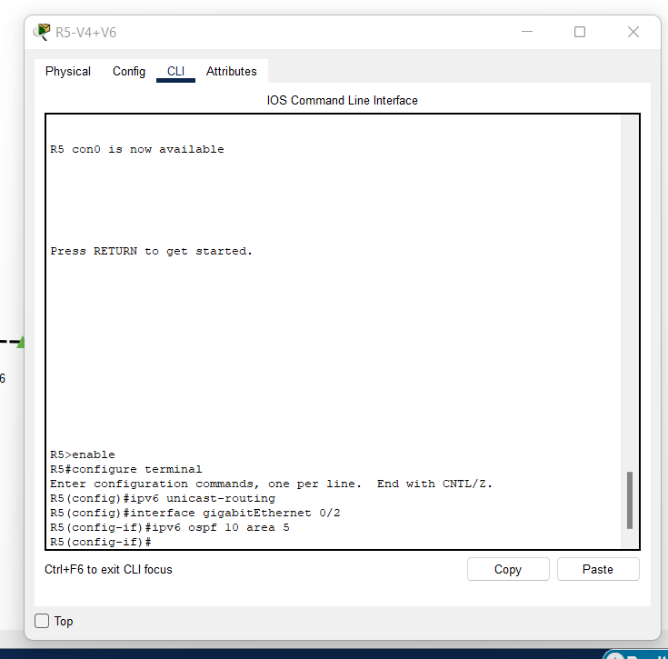**Single area ospf using ipv6 for R5:**

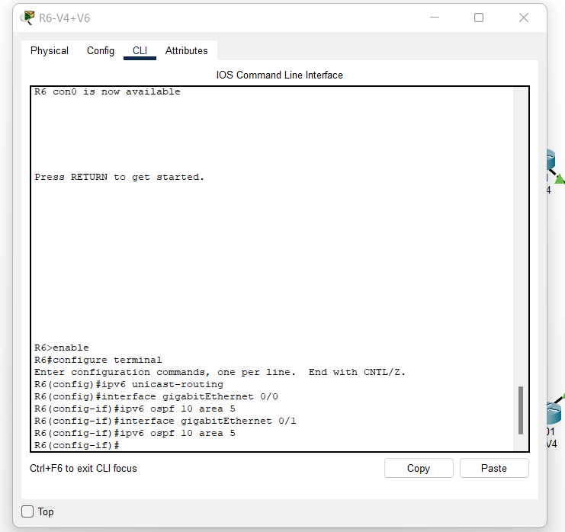**Single area ospf using ipv6 for R6:**

# Tunnel

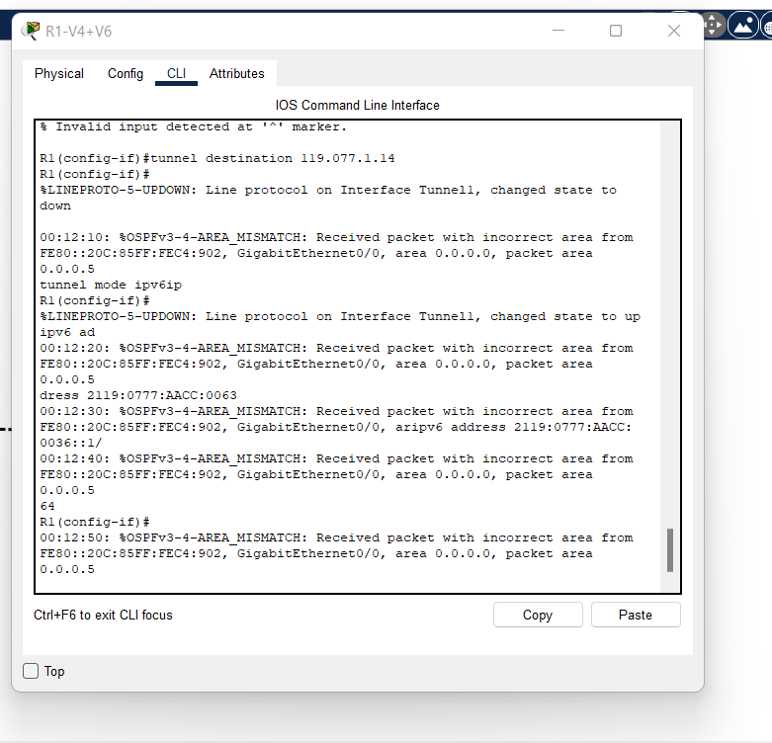Tunnel for R1:

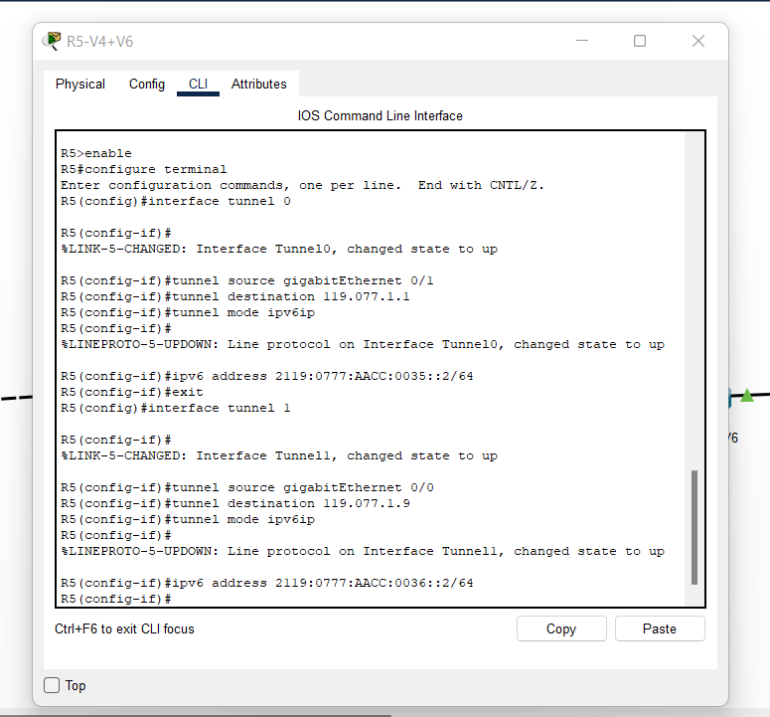Tunnel for R5: